Chart of accounts
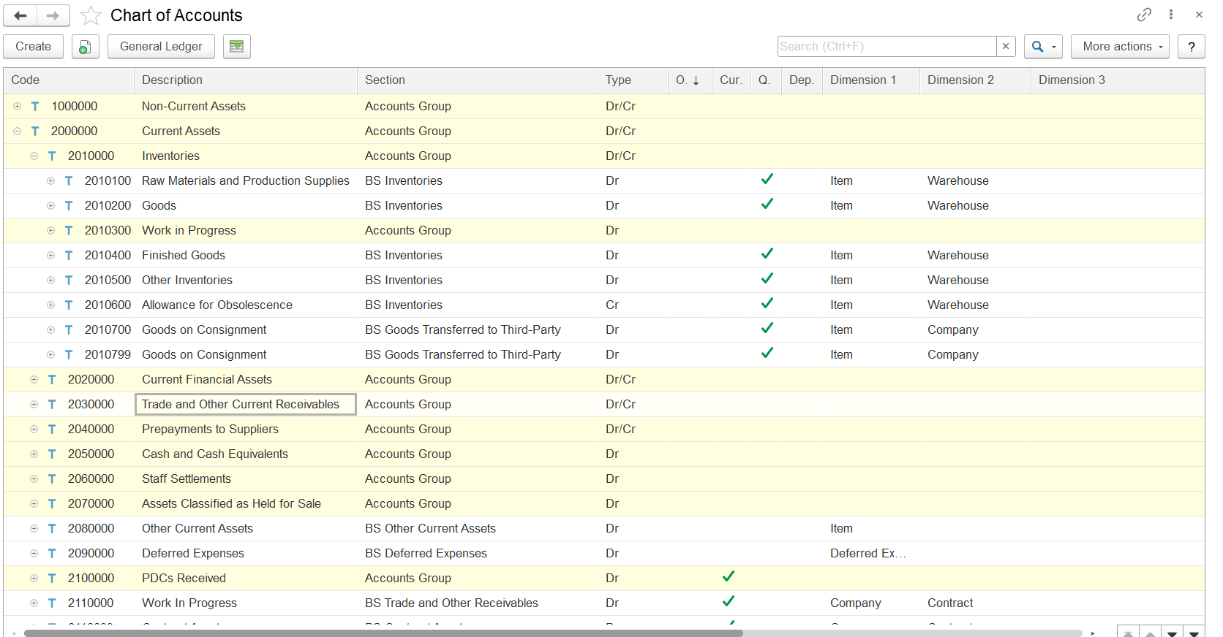
Generally, the accounts on the chart of accounts are listed by type as follows:
- Balance Sheet Accounts: Assets, Liability, Equity
- Income Statement Accounts: Income and Expense
Further, the accounts are grouped in sections by business function (such as production, product lines, sales, administrative, and so forth).
If the Quantitative check box is selected for the account, the data recorded for the account include quantities along with amounts. For example, quantitative accounting is used for inventory.
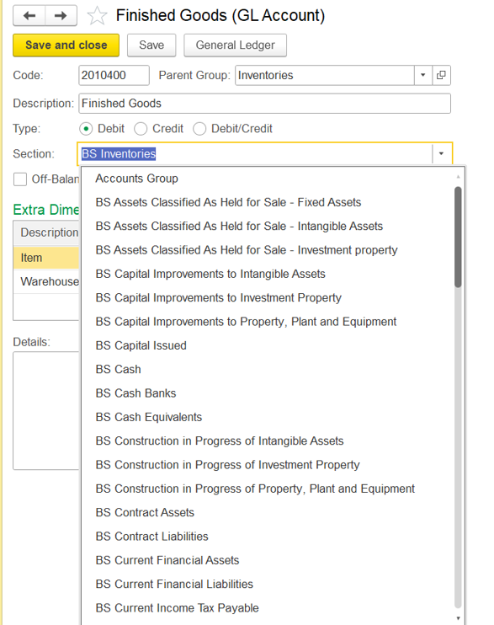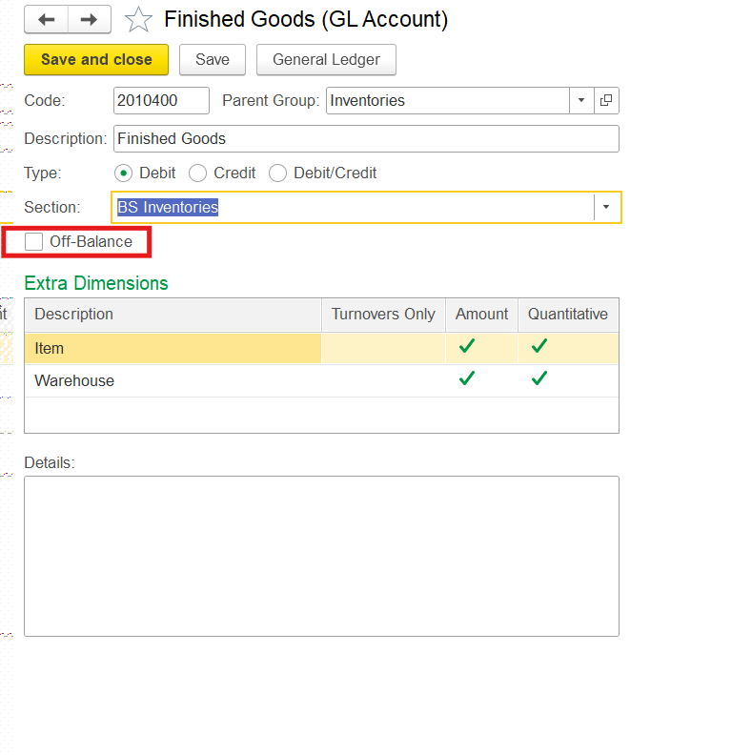

- Accounts Group
- BS Assets Classified As Held for Sale - Fixed Assets
- BS Assets Classified As Held for Sale - Intangible Assets
- BS Assets Classified As Held for Sale - Investment property
- BS Capital Improvements to Intangible Assets
- BS Capital Improvements to Investment Property
- BS Capital Improvements to Property, Plant and Equipment
- BS Capital Issued
- BS Cash
- BS Cash Banks
- BS Cash Equivalents
- BS Construction in Progress of Intangible Assets
- BS Construction in Progress of Investment Property
- BS Construction in Progress of Property, Plant and Equipment
- BS Contract Assets
- BS Contract Liabilities
- BS Current Financial Assets
- BS Current Financial Liabilities
- BS Current Income Tax Payable
- BS Current Income Tax Receivable
- BS Current Other Tax Payable
- BS Current Other Tax Receivable
- BS Deferred Expenses
- BS Deferred Revenue
- BS Deferred Tax Assets
- BS Deferred Tax Liabilities
- BS Fixed Assets Acquired
- BS Goods Transferred to Third-Party
- BS Input VAT
- BS Intangible Assets
- BS Inventories
- BS Investment Property
- BS Non-Controlling Interests
- BS Non-Current Contract Liabilities
- BS Non-Current Deferred Expenses
- BS Non-Current Deferred Revenue

- BS Non-Current Financial Assets
- BS Non-Current Financial Liabilities
Pl Account list 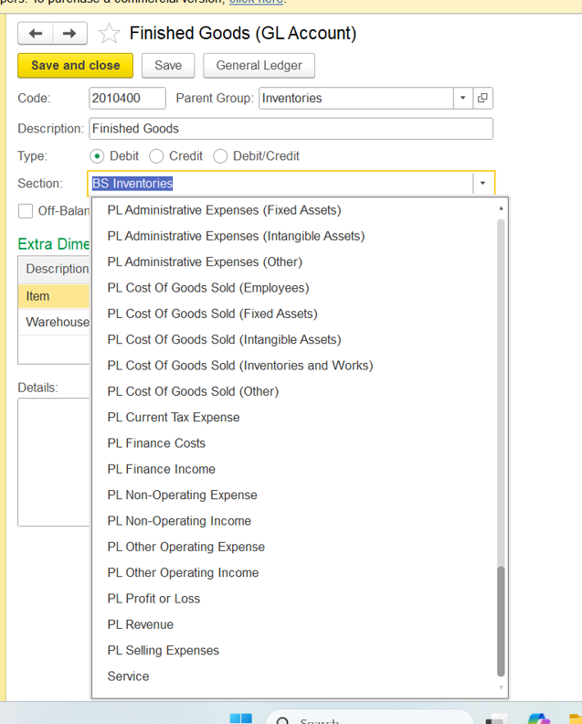

1. Type (Debit, Credit, Debit/Credit):
- This specifies the normal balance type for the GL account. For inventory accounts like Finished Goods, "Debit" is typically selected because inventory is an asset and assets usually have debit balances.

2. Section (BS Inventories):
- This field links the GL account to a specific section of the Chart of Accounts (COA). "BS Inventories" means this account is part of the Balance Sheet under Inventories, which is standard for finished goods inventory.

3. Extra Dimensions:
- This section allows you to define additional analytical dimensions for the account. In your example:
- Item: This dimension is tracked for both Amount and Quantitative (quantity) values.
- Warehouse: This dimension is tracked for Amount only.
- These dimensions enable more detailed tracking and reporting, such as knowing the value and quantity of finished goods by item and by warehouse.

4. Other Fields:
- Code: The unique identifier for the GL account (e.g., 2010400).
- Parent Group: The higher-level group in the COA under which this account falls (Inventories).
- Description: A brief description of the account.
- Off-Balance: If checked, this would make the account an off-balance sheet account (not checked in your screenshot).
- Details: A free-text field for any additional notes.

This setup ensures that all transactions involving finished goods are properly categorized in the accounting system, with the ability to analyze balances and turnovers by item and warehouse, supporting accurate inventory and financial reporting.
Cash Equivalents
Cash Equivalents are items that are similar to cash such as short-time investment securities, that can be cashed out rather easily and quickly. Long term investment and short term investments
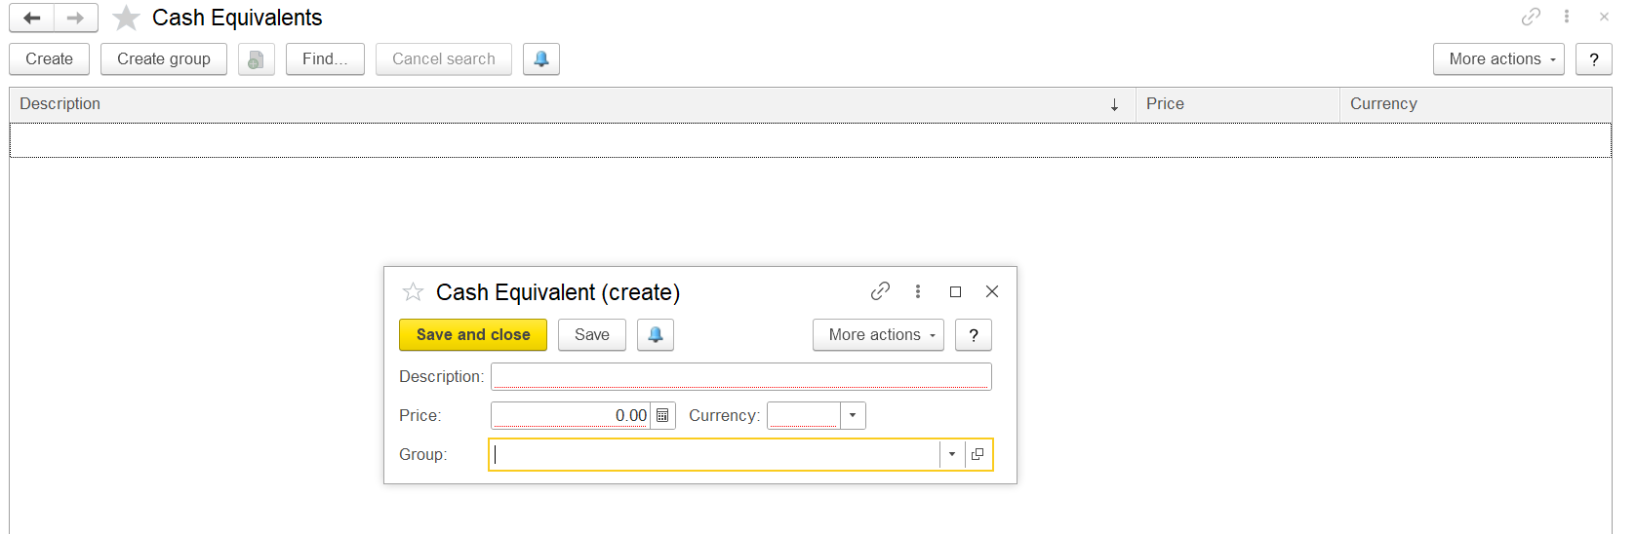

Cash flow items
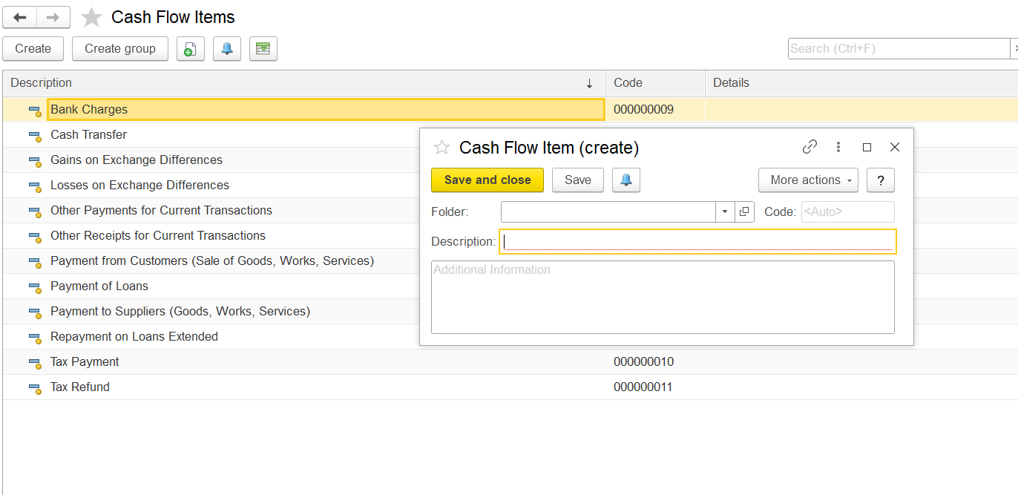
Expense Items
Resource types: Inventory, Fixed asset, manpower, all and Services
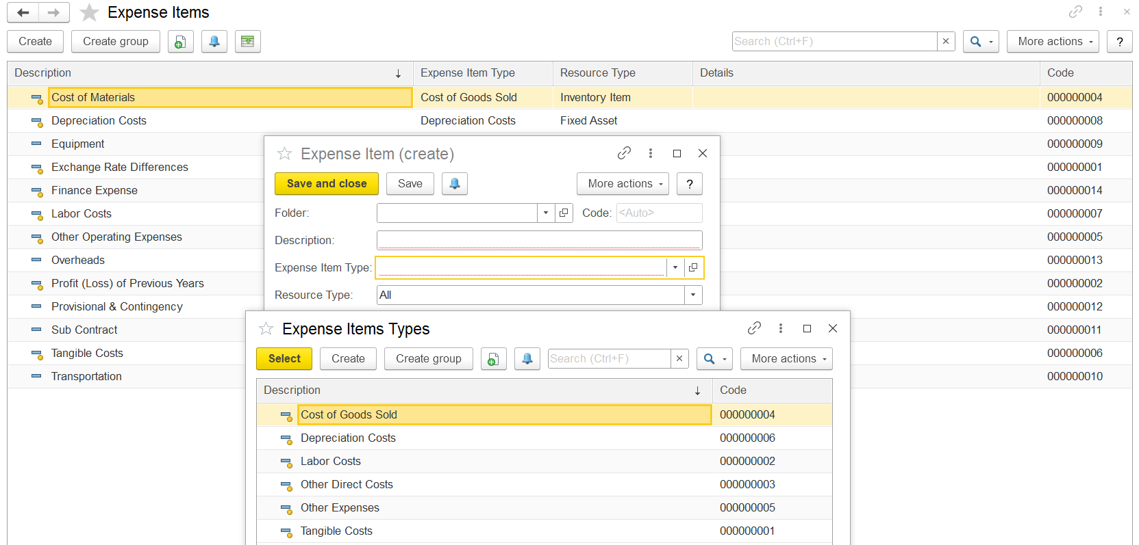

Income Items
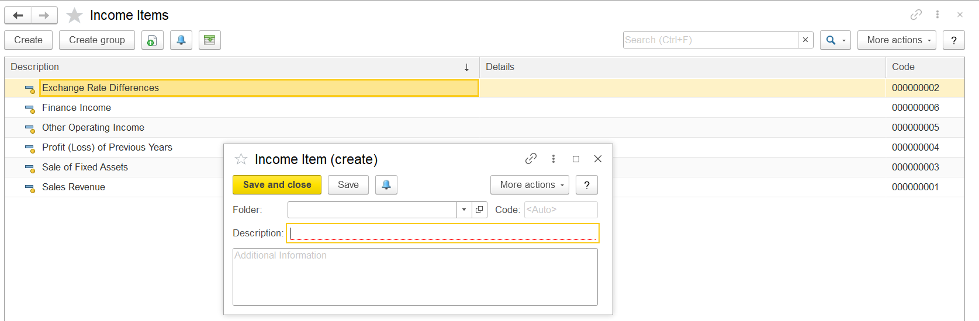
Entering the item as service and inventory (Product the Default GL accounts will be)
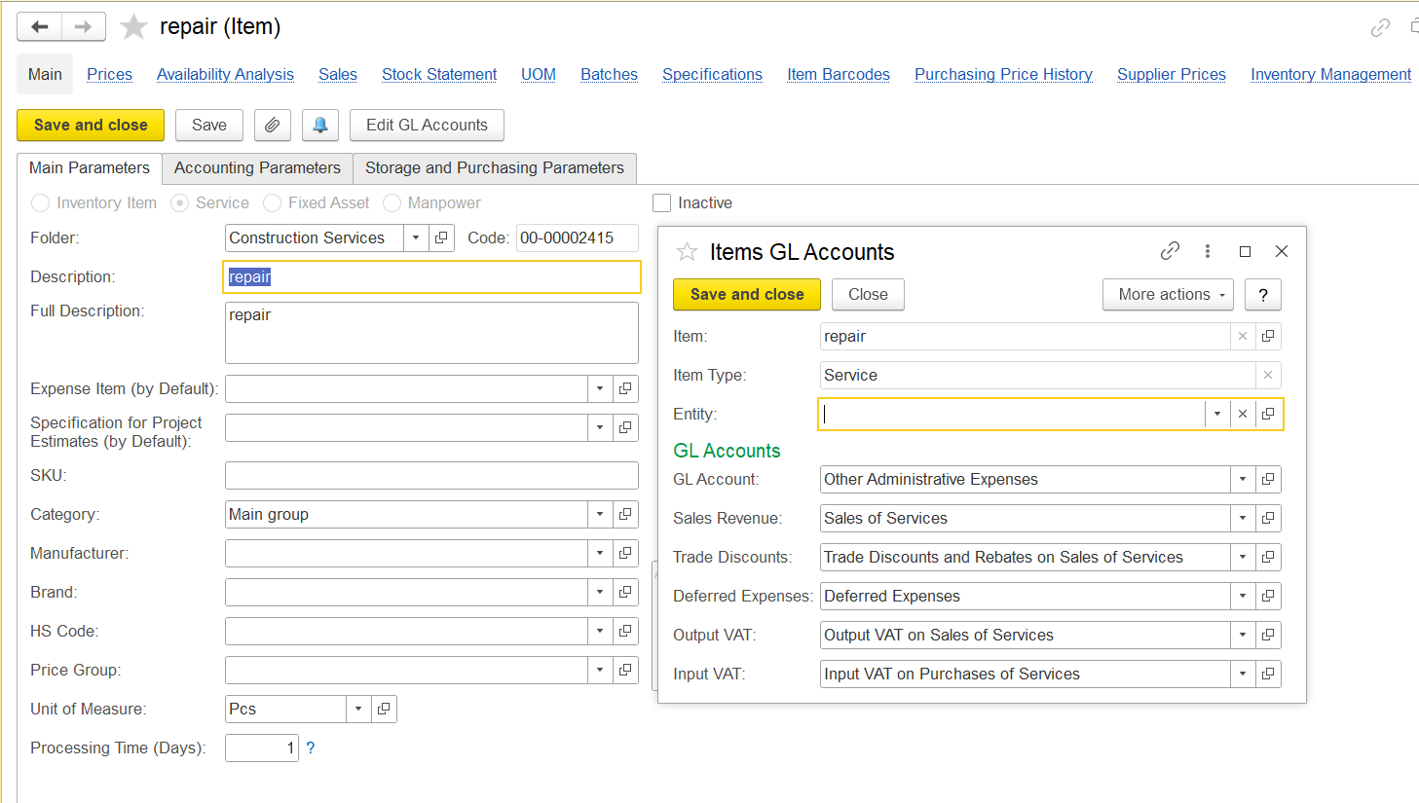
Inventory
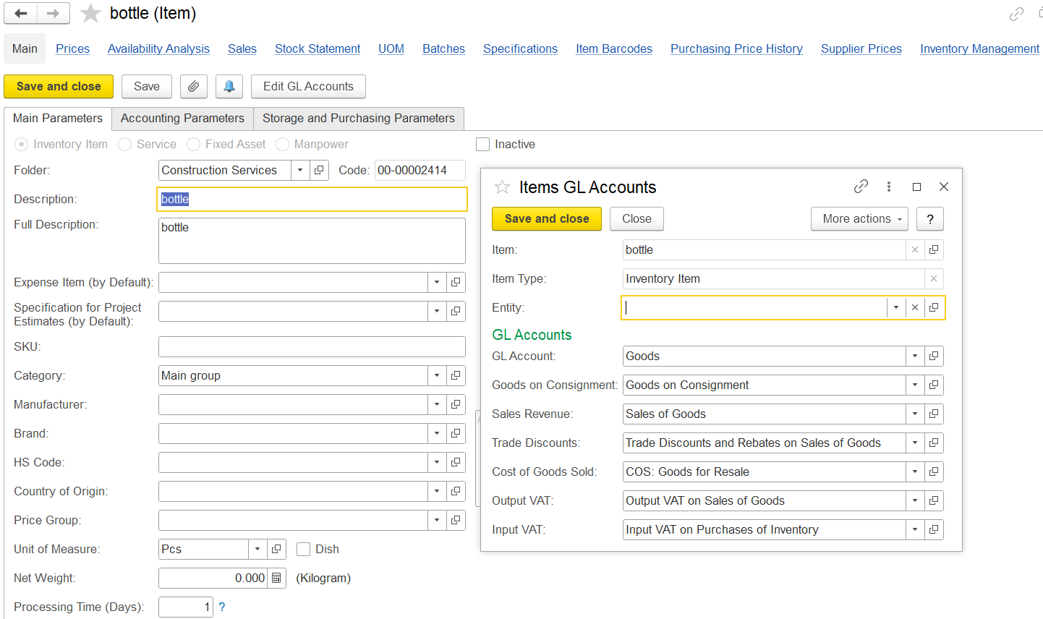
Fixed assets
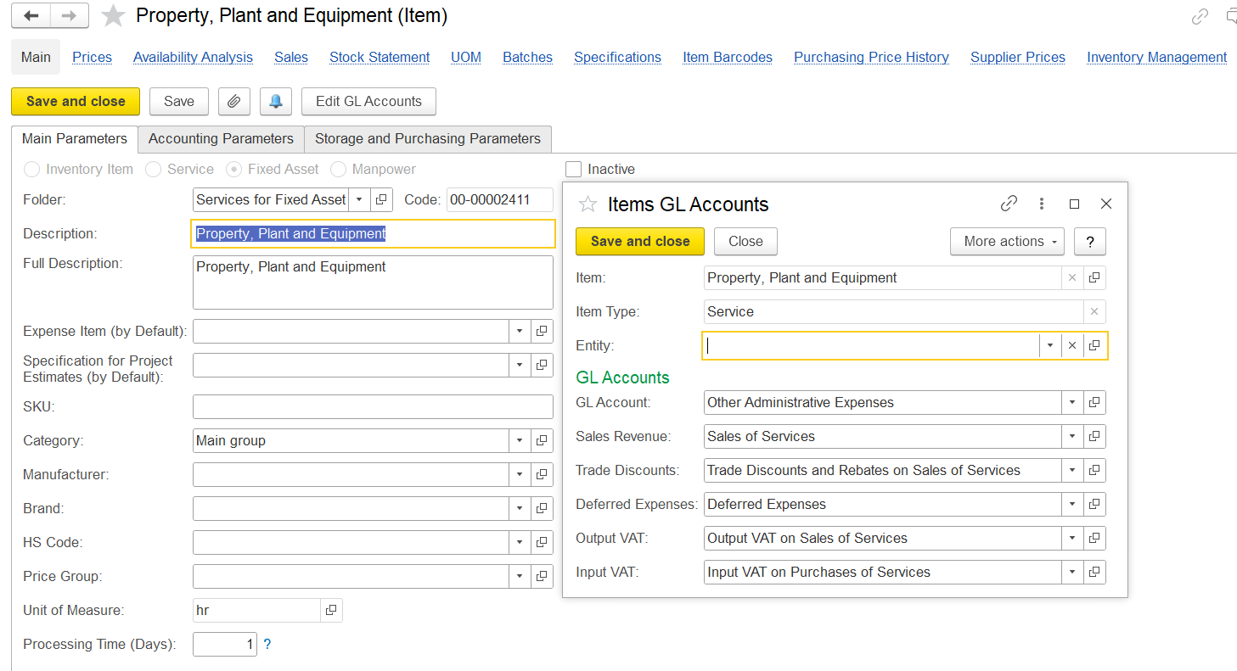
manpower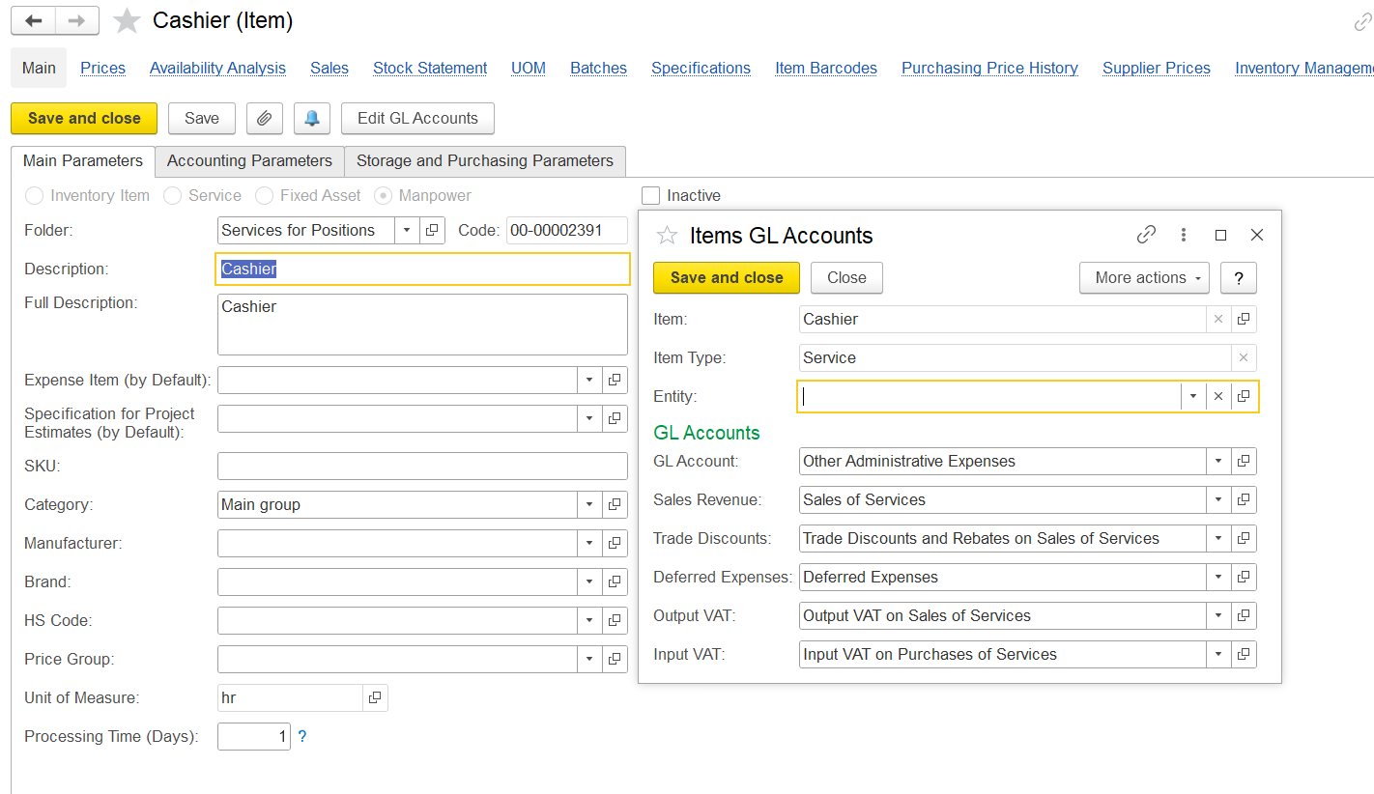

Purchase Default accounts when processing the Invoice received
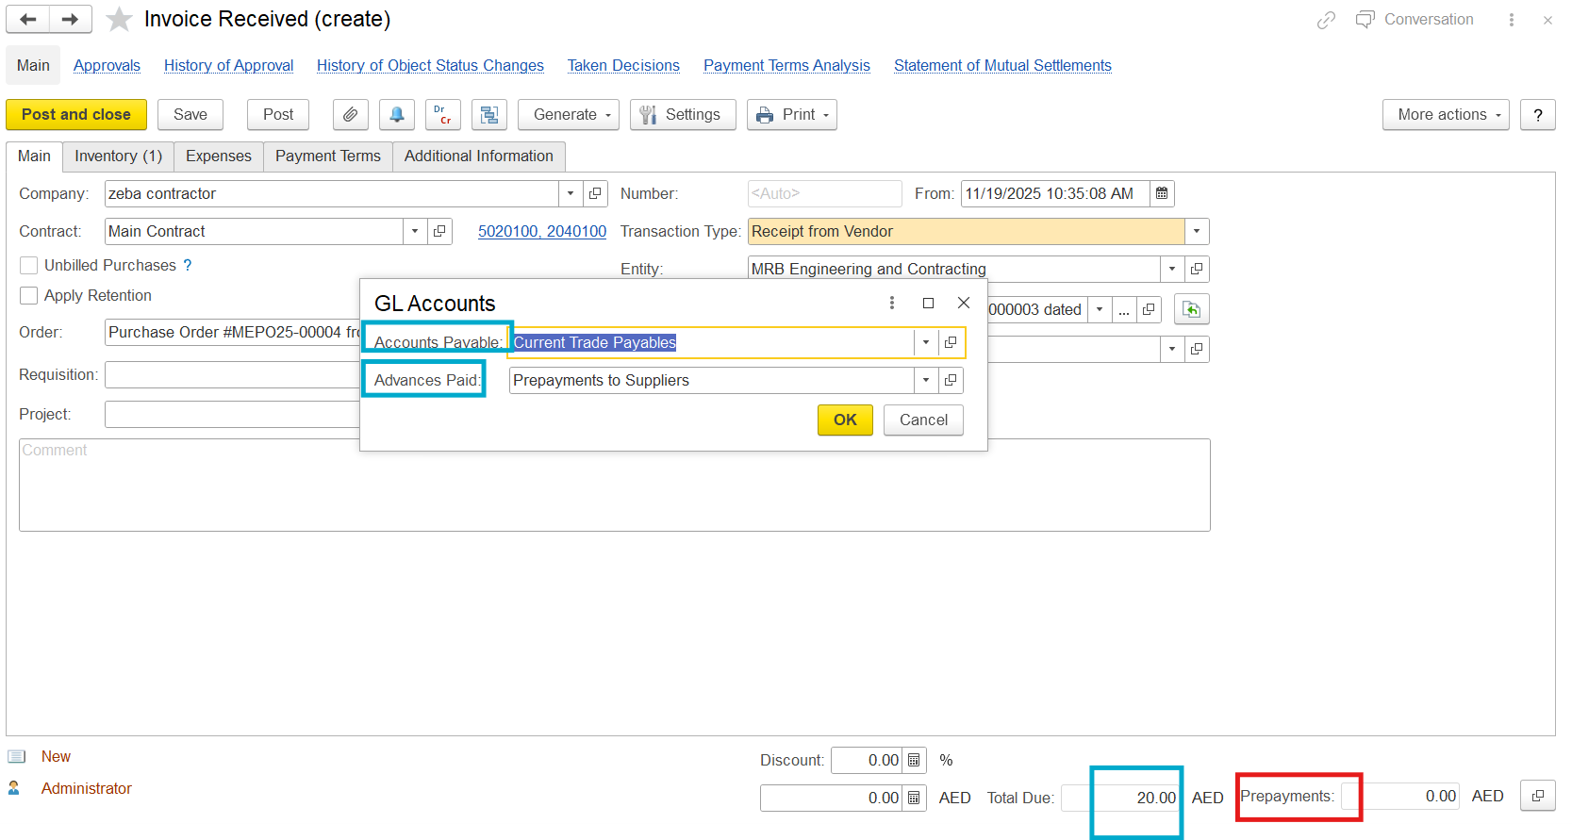
Debit Goods and Credit Current trade payables
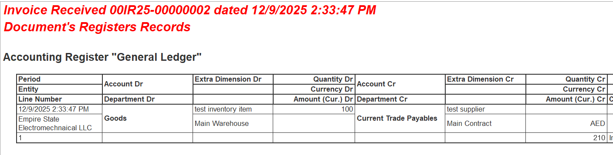

Cashflow Statement
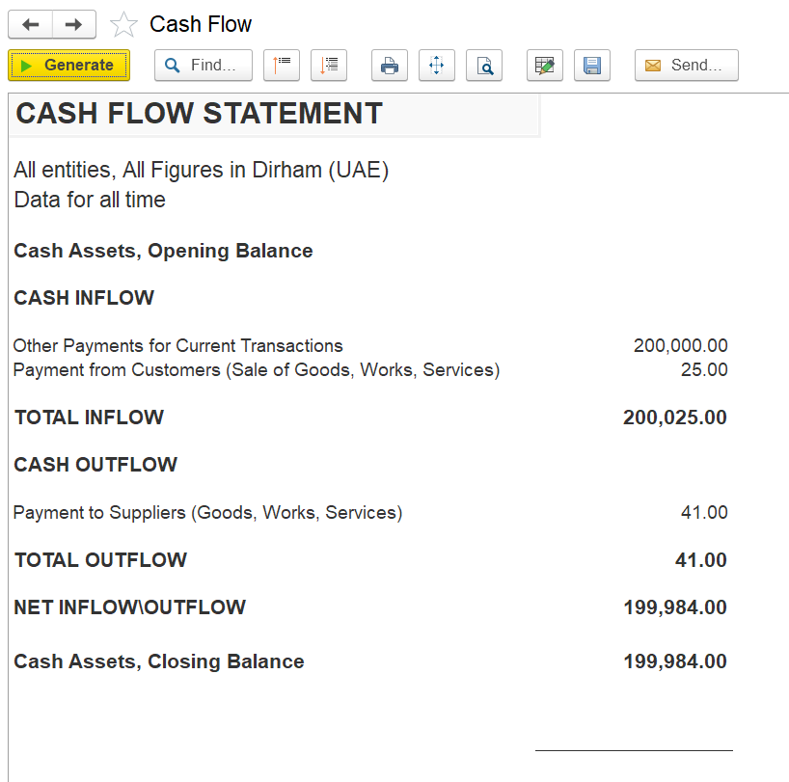
Balance Sheet
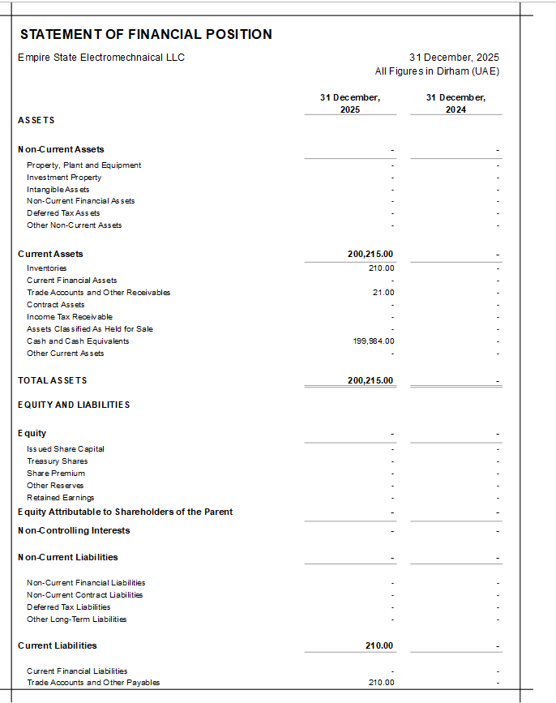
Owners equity
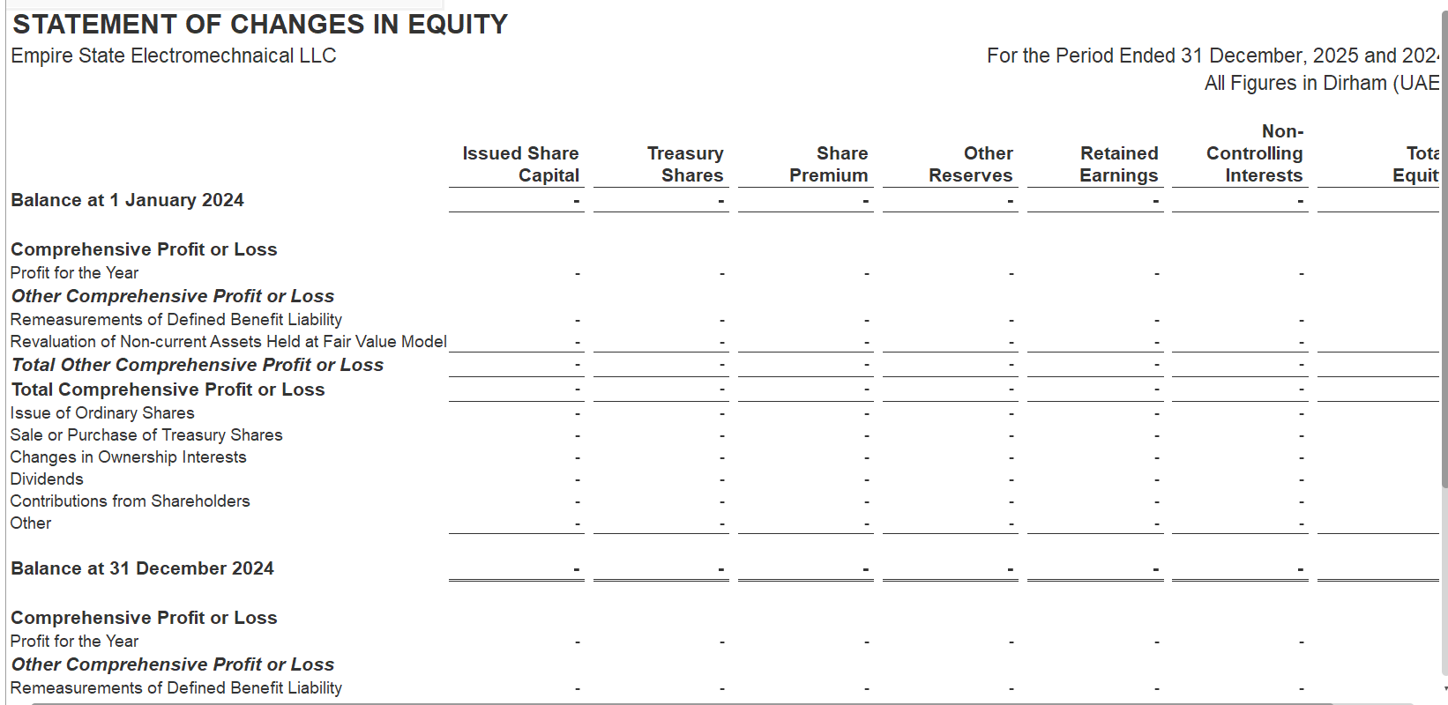
Expenses and VAT
Dr Input Vat on purchases and cr Current Trade payables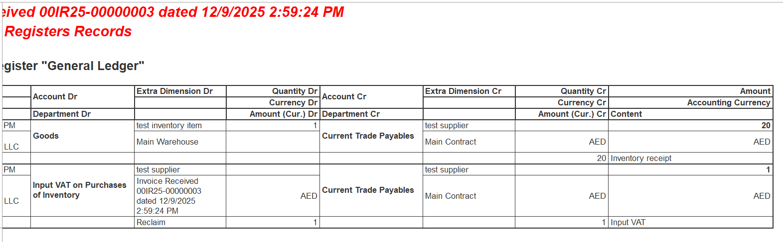
Dr Other administrative expenses and Cr Current Trade Payables
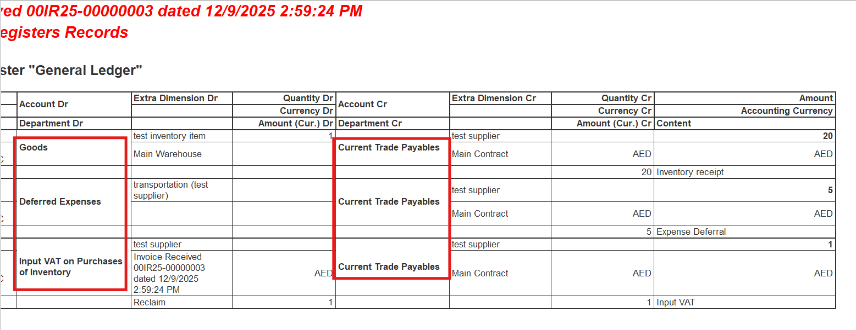
When making the purchase payment the GL accounts
Dr the Current Trade payable and Cr the Bank account(If bank payment)
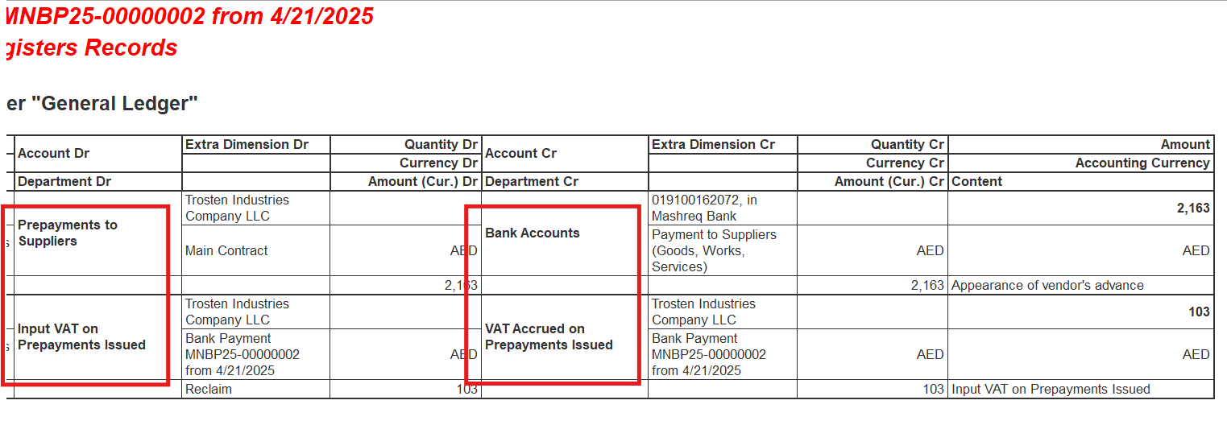
Dr the current Trade payable and Cr the cash on hand (If cash payment)
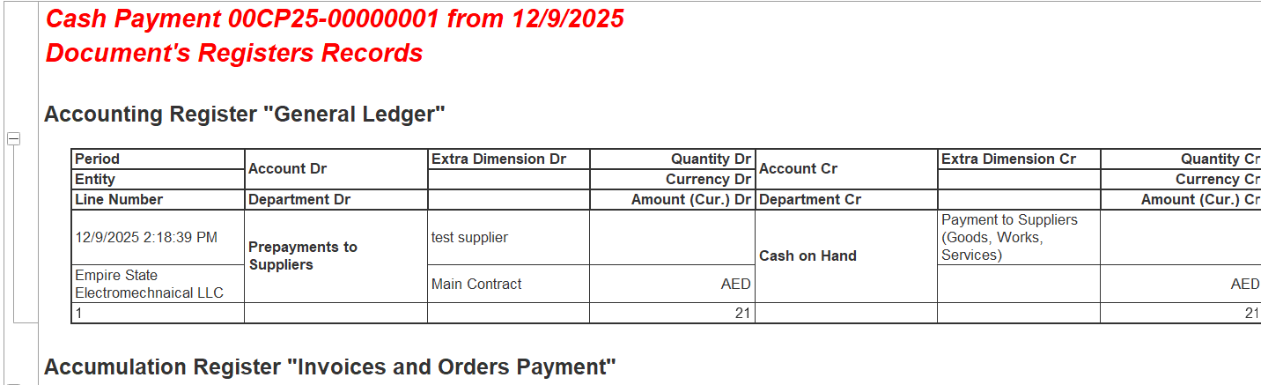
Dr the Current Trade Payable and Cr the PDCs Issued to companies(If Cheque payment cheques date clearing tab and cheque number all those things we need to add if they are any bank charges)
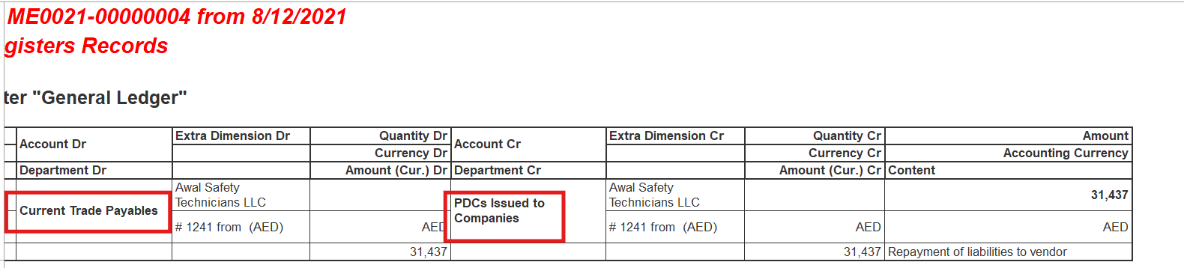
Return of Goods:
Dr | Cr
Sales of the Goods | Prepayment from customer
Goods | COS: Goods for resales
Current VAT Payable | Prepayment From Customer

Debit note Invoice Correction
Dr | Cr
Goods | Prepayments to suppliers
Prepayment to supplier | Current Trade Payables
Mutual settlement

Default customer accounts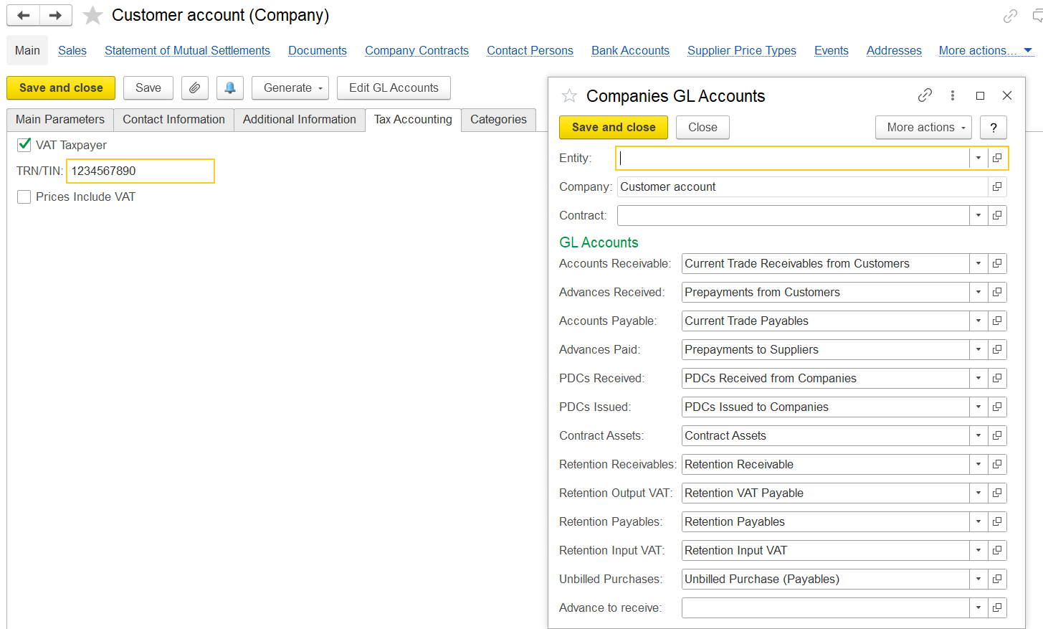
Default Supplier accounts: 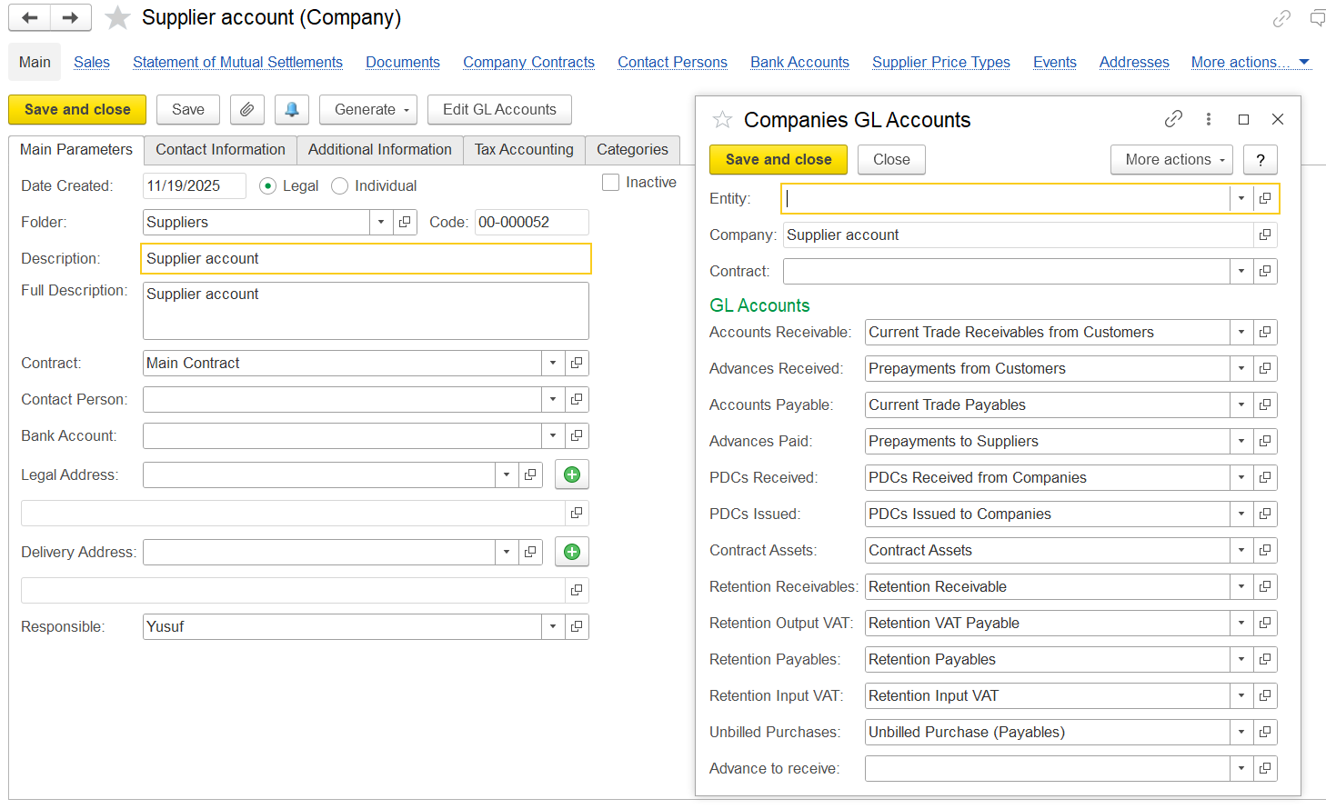
Document Register
Customer Invoice GL accounts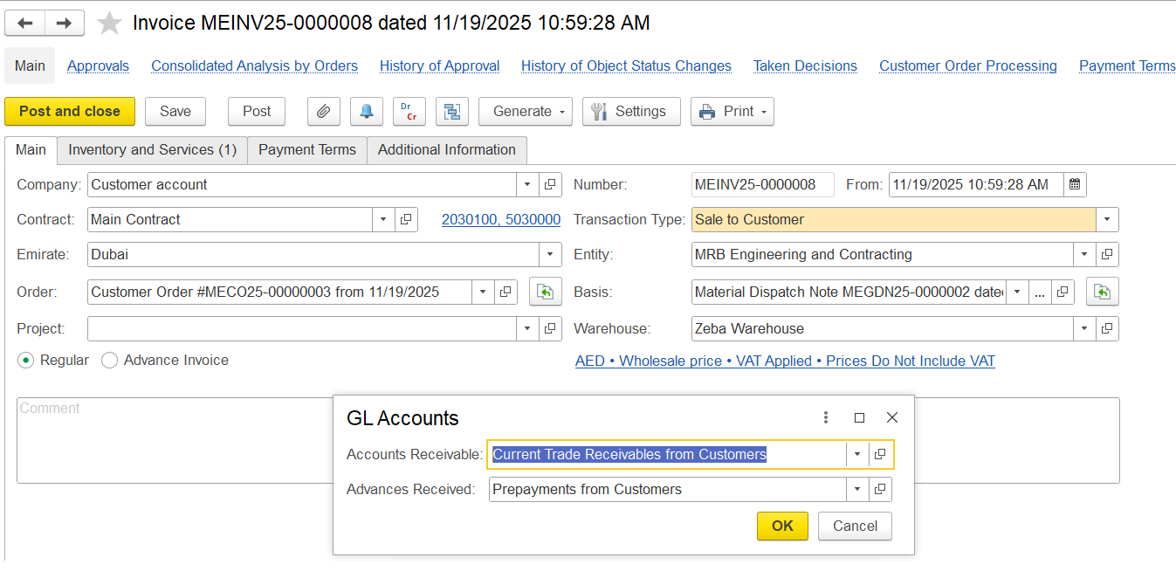
Trade Receivables Dr and Sales of goods Cr
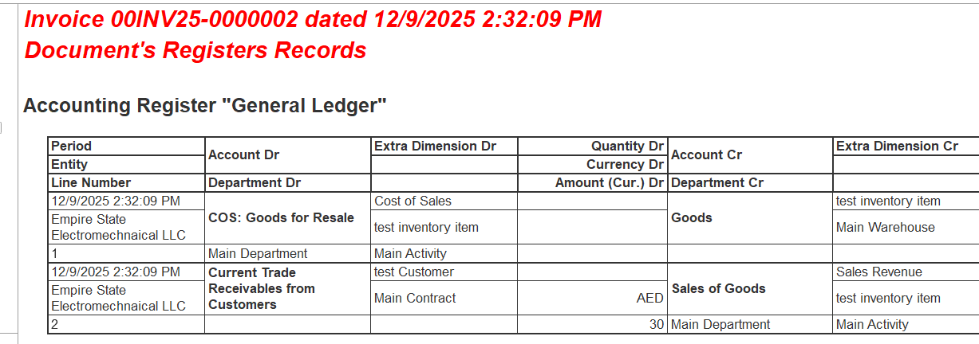
If VAT and discount is added
Trade Receivables Dr for the Vat Amount and Current VAT payable Cr
Output vat
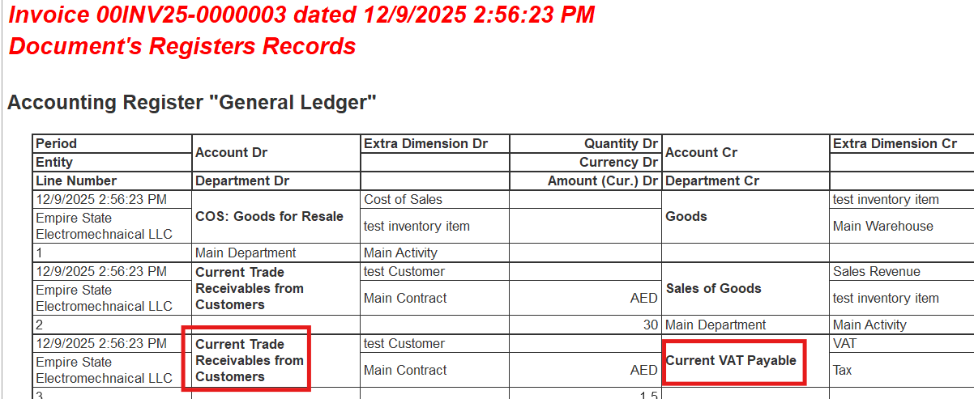
Trade Discount and Rebates on sales Dr and Cr Sales of Goods

Expenses booking

Payments
Receiving a Bank payment: Bank account Dr and Current Trade Receivables Cr
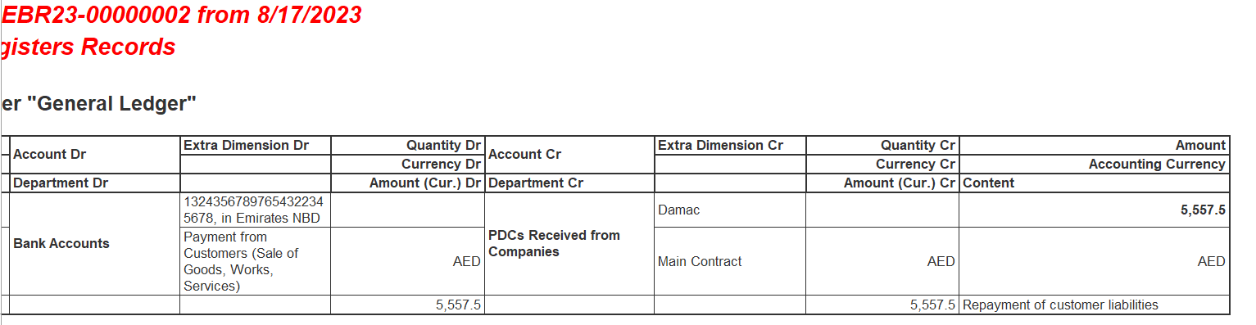
Receiving a cash payment: Cash on hand Dr and Current Trade Receivables Cr
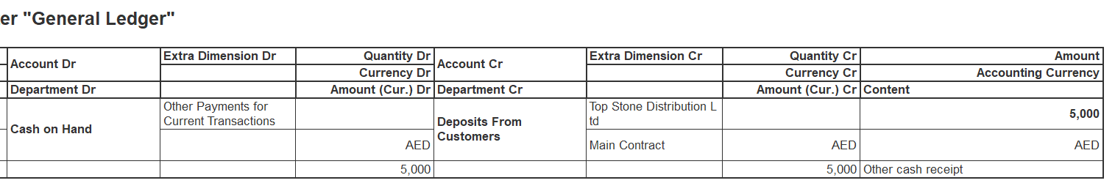
Receiving a Cheque:PDCs Received form Companies and Current Trade Receivables Cr
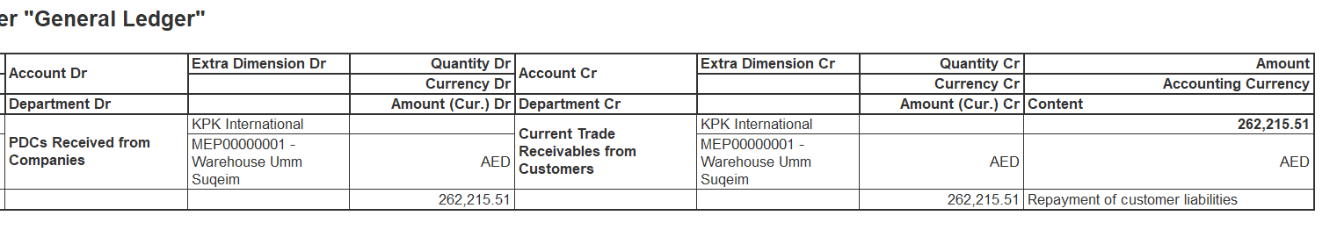
Credit Note booking
Mutual Settlement
Dr Other operating expenses and Cr current Trade Receivable form Customers
Invoice Correction Credit Note
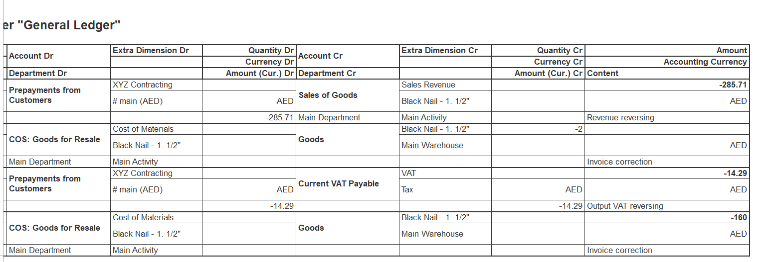
Dr | Cr
Prepayment from the customer - | Sales of goods
Current trade receivable from customer | Prepayment from customer
Payment from customer | Current Vat Payables
Return of Goods:
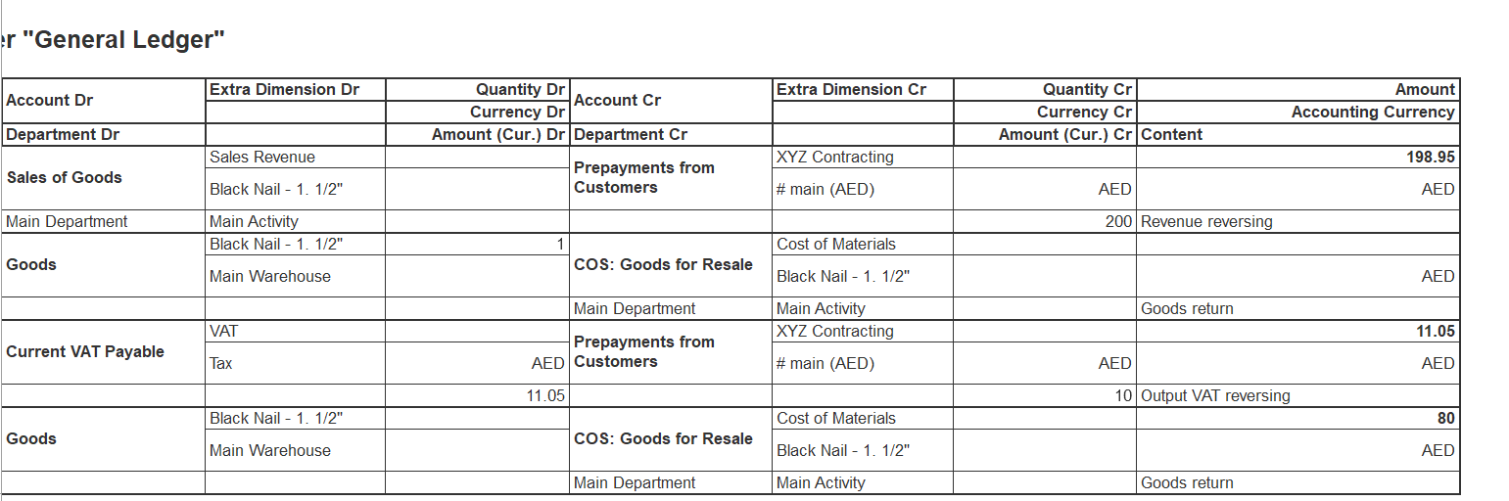
Dr | Cr
Sales of Goods | Prepayments from Customer
Goods | COS: Goods for resales
Prepayment from Customer | Current trade receivable from Customer
Current VAT Payables | Prepayment from customer
Goods | COS: Goods for resale

Warehouse GL Accounts
Inventory Transfer
DR Goods to destination warehouse Cr Goods to Source Warehouse
Inventory Write off.
Dr other operating expenses and cr Goods
Inventory Receive
Dr Goods Cr other operating income
Project Costing Module Invoicing
VAT
VAT Settings
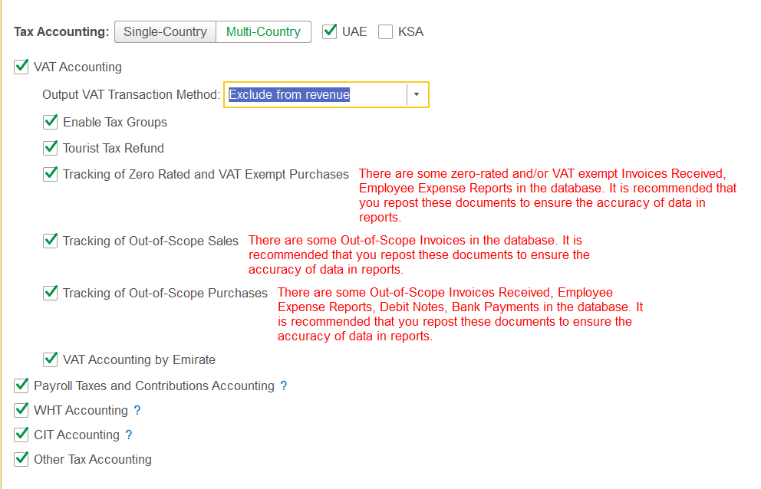
VAT Group
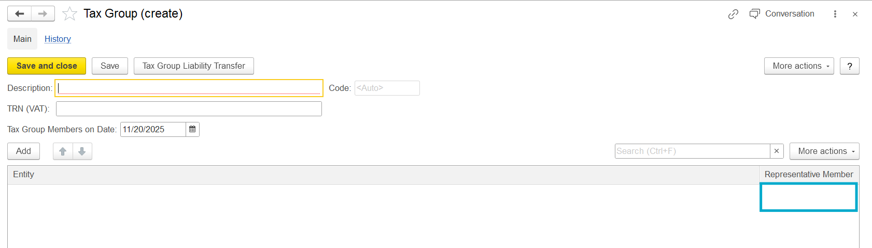
VAT Types:
Current TAX Receivable: Current VAT receivable(GL Account)
Current TAX Payable: Current VAT Payables(GL Account)
Adding the TAX Type and the edit GL account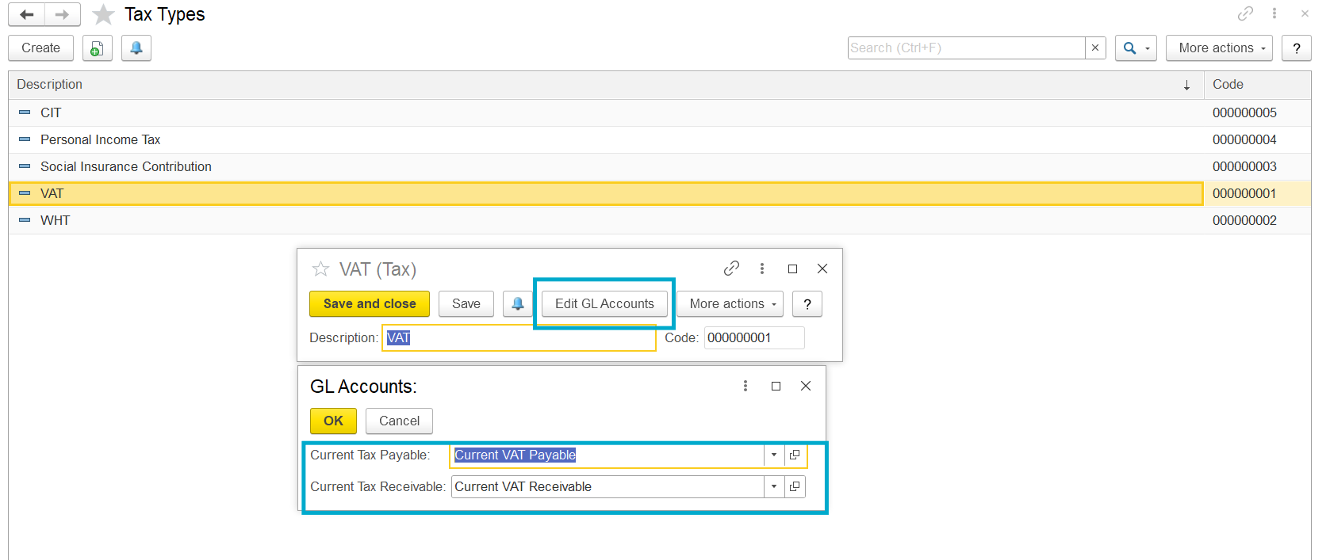

VAT Rates:
0%, 5% Exempted, out of scope.
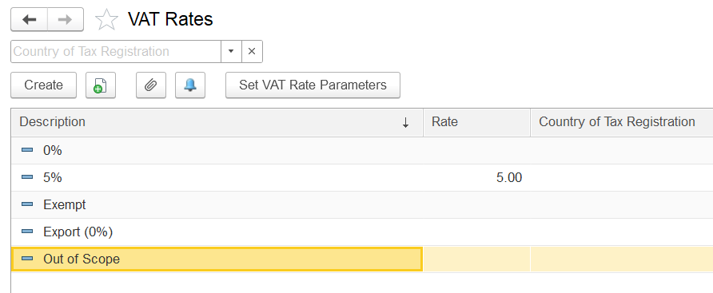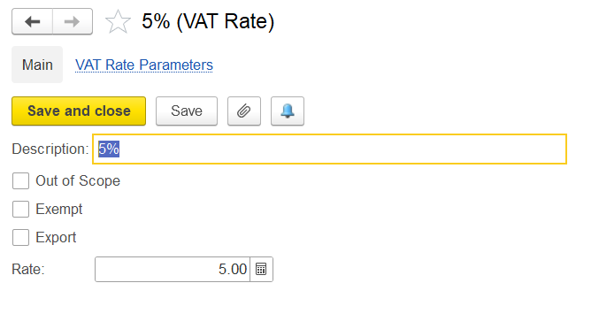

Out Of scope VAT Reasons: Form for create
- Intra company Transaction
- The company is not registered for VAT
- The Product is not subject to VAT
TAX codes applicable in UAE 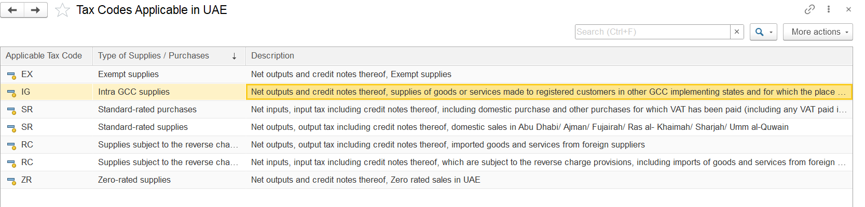
Tax Transactions:
Tax Transactions are created manually when you need to register tax penalties or correct some manual tax transactions. The system generates tax transactions when it is needed to transfer tax liabilities for a tax period within tax groups.
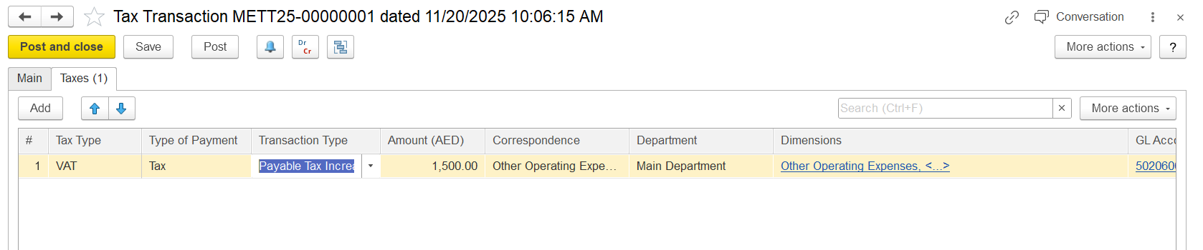
Types of payment: Tax, penalties, Interest and Tax Prepayment
Transaction type: Payable Tax Increase, Payable Tax Decrease, Recoverable Tax Increase and Recoverable Tax Decrease
Payable Tax Increase: Used when you need to increase the amount of tax payable to the authorities.
- Payable Tax Decrease: Used when you need to decrease the amount of tax payable.
- Recoverable Tax Increase: Used when you need to increase the amount of tax that can be recovered (input VAT).
- Recoverable Tax Decrease: Used when you need to decrease the amount of recoverable tax.
After this entry the statement of tax account will be updated in VAT Amount
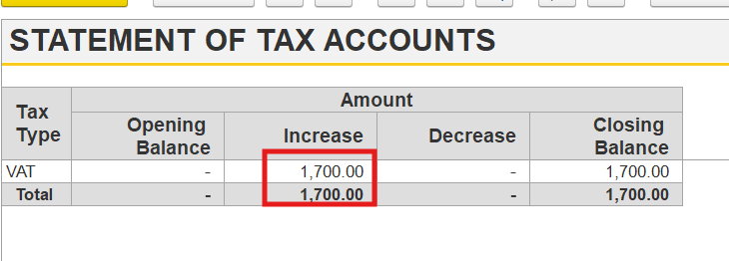
VAT Return File
You can create the file 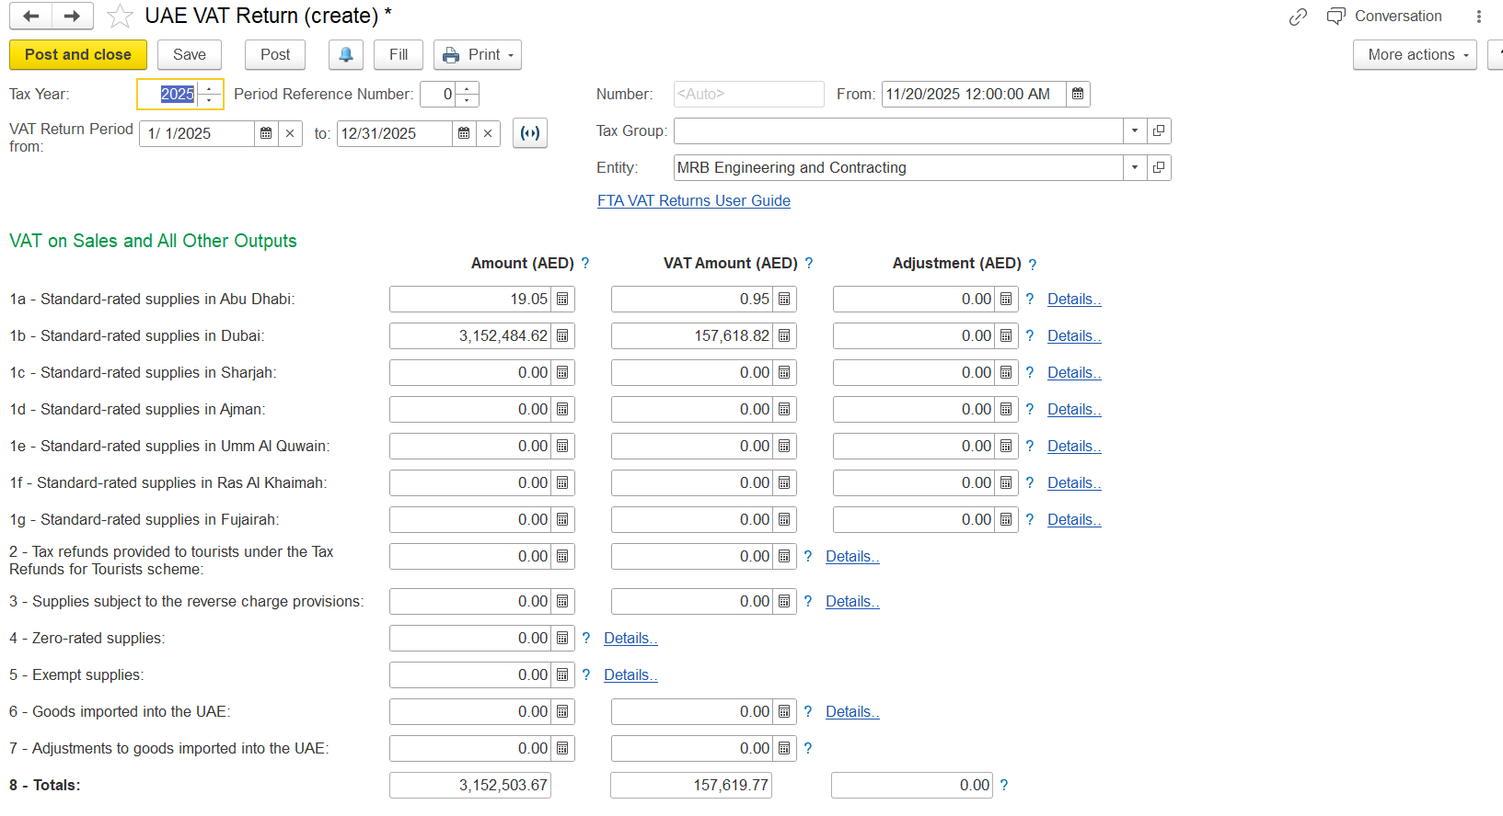 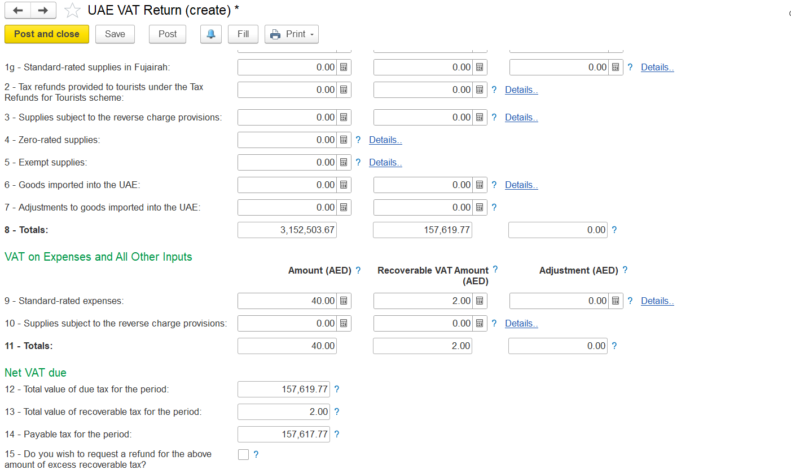
Then a print form we will be getting
Calculation of VAT Liability
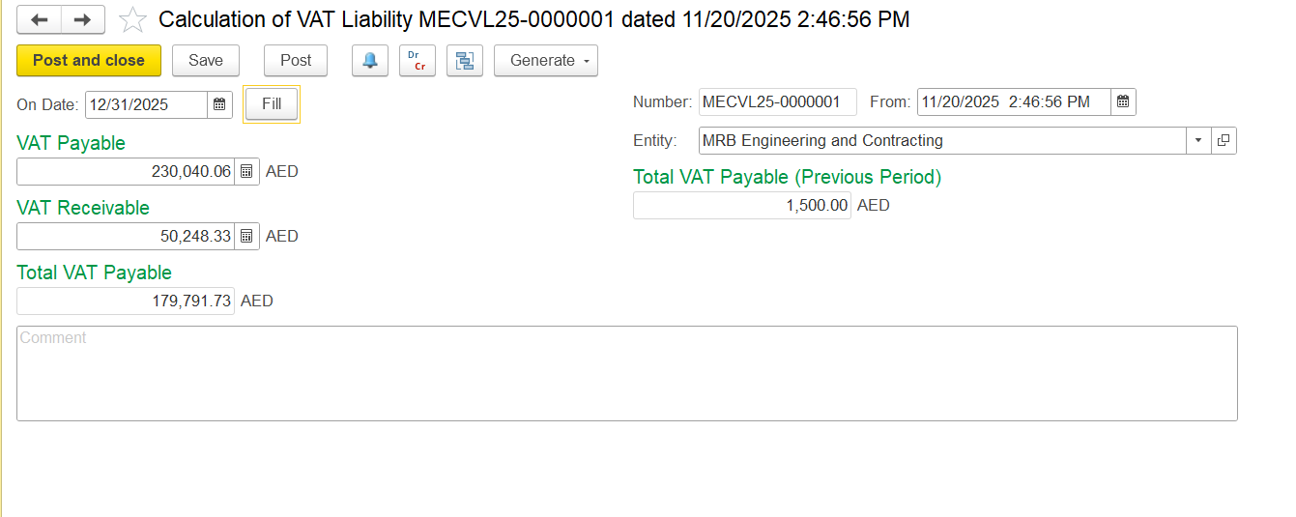
Then we pay that using bank the GL accounts will be Dr the current VAT payable Cr the bank Account

VAT Output Transaction
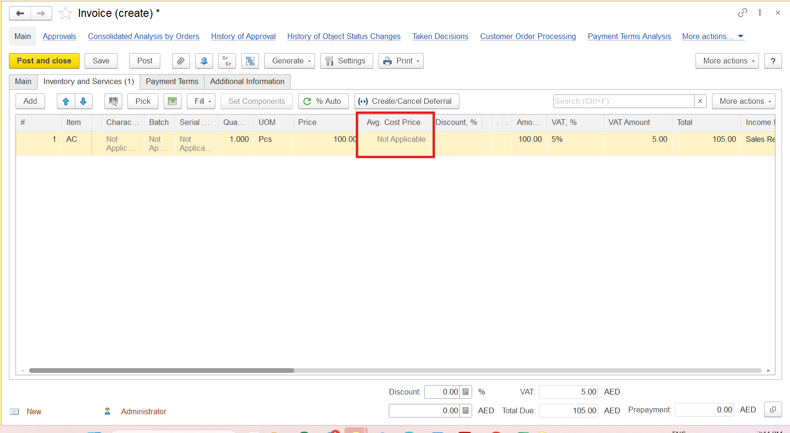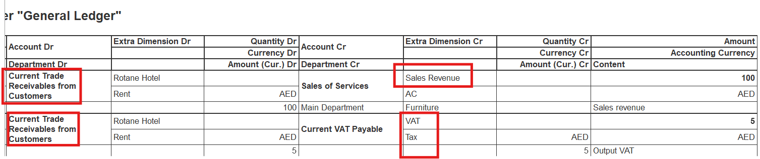
VAT Input Transaction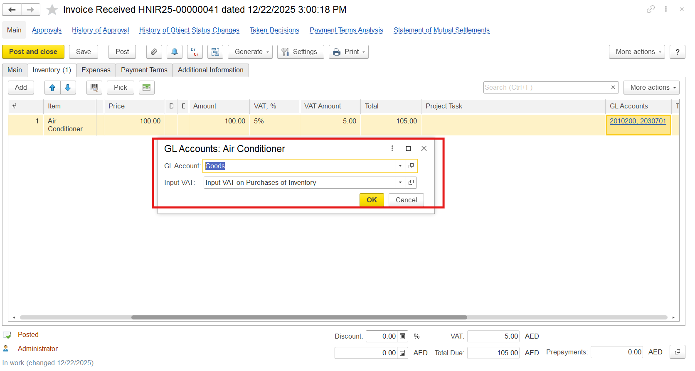
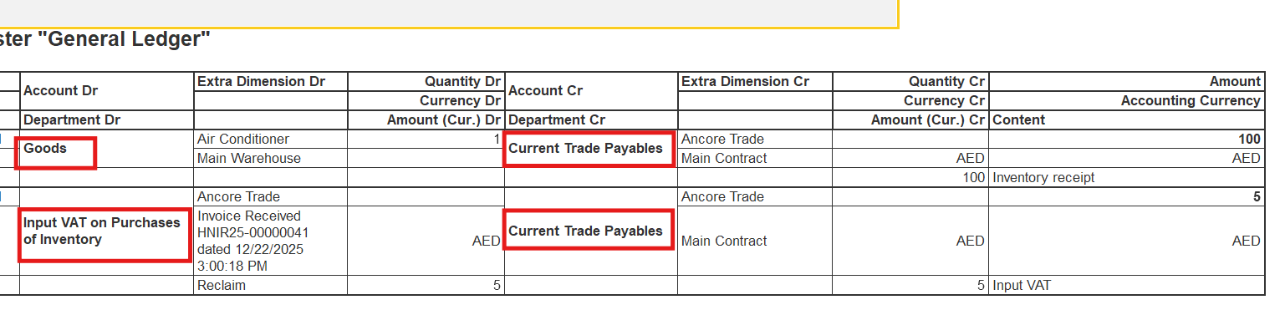
Trial Balance with turnovers
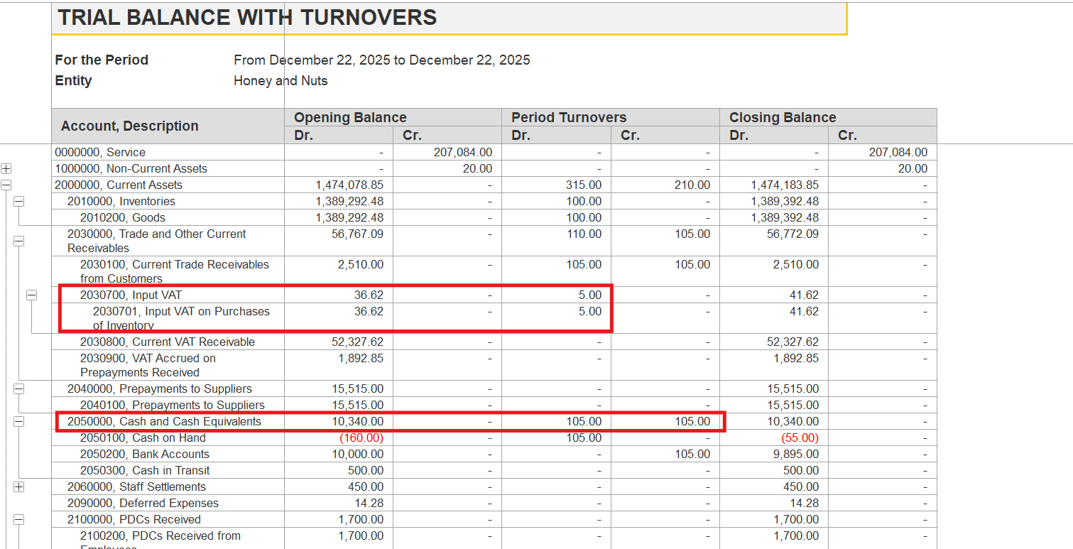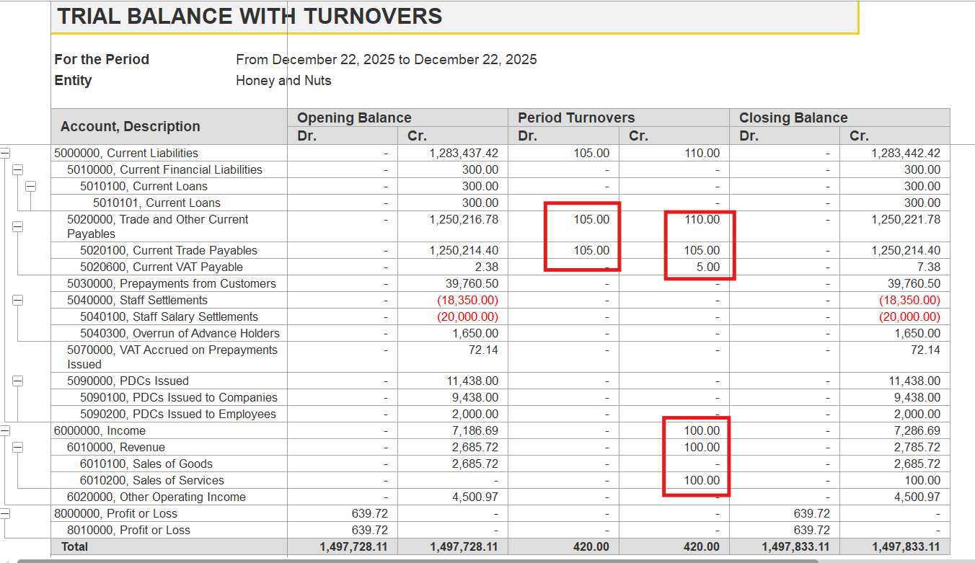
Income statement Profit and Loss yearly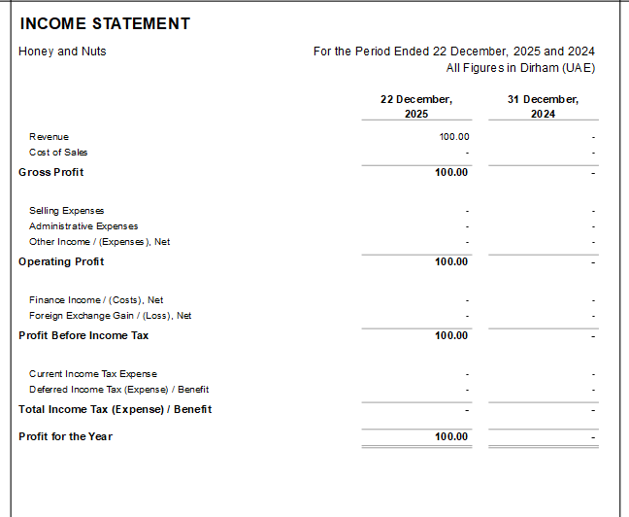### 1. Posting Reports for Documents
After processing (posting) a document like "Invoice Received," you can view a posting report that provides detailed information on the generated GL transactions. This report shows which GL accounts were affected by the document and the corresponding amounts. To view this, open the document and use the posting report function on the toolbar. For example, for an invoice, you will see the GL transactions generated for each item, including inventory, VAT, and payables.

### 2. General Ledger
All GL transactions, whether generated automatically or posted manually, are recorded in the General Ledger. You can analyze these transactions for any selected period using filters and options available in the General Ledger form. This allows you to see all movements on the selected GL accounts, including those from invoices, payments, and other documents.

### 3. Trial Balance and Trial Balance with Turnovers
GL Accounts will appear in the Trial Balance and Trial Balance with Turnovers reports. These reports show the opening and closing balances, as well as the turnovers (debits and credits) for each GL account. If dimensions such as Item or Warehouse are set for the account (e.g., for Goods accounts), the report can display balances and turnovers by these dimensions as well.

### 4. Financial Statements
GL Accounts are reflected in financial statements such as:
- Income Statement (P&L): Shows revenues, costs, expenses, and profits. You can enable the "Show Details by GL Accounts" parameter to display the specific GL accounts under each group in the report. Double-clicking on a GL account value provides further details, such as the account's trial balance or statement.
- Statement of Financial Position (Balance Sheet): Displays assets, liabilities, and equity, grouped by GL account sections.
- Statement of Account: Shows detailed movements and balances for a specific GL account.

### 5. Other Reports
Depending on the type of transaction and the GL account section, accounts may also appear in:
- Work in Progress Balances, Statement of Work in Progress (for WIP accounts)
- Statements of Accounts (for payables, receivables, etc.)
- Production and Cost Reports (for inventory and manufacturing-related GL accounts).

### Important Notes
- The section of the GL account (e.g., Asset, Liability, Income, Expense) determines in which financial statement or report the account will appear.
VAT
Deferred Expenses
Once we are adding up the deferred expense in the purchase invoice
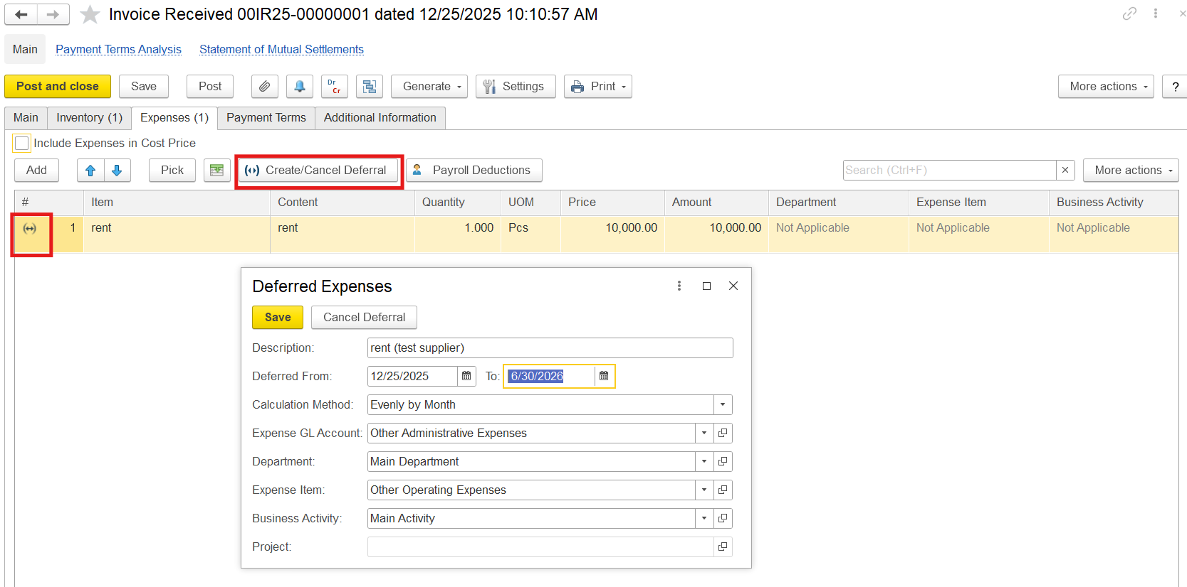
Then you can enter the Expense Recognition :It will calculate as per monthly , Manually or day wise how you want to select you can select the method
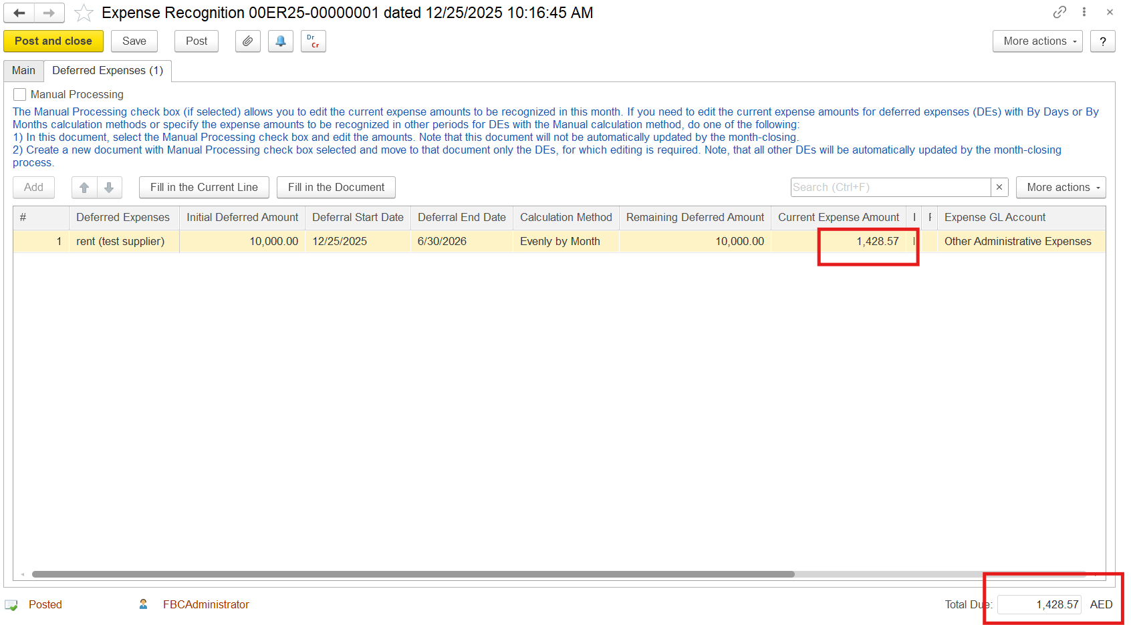
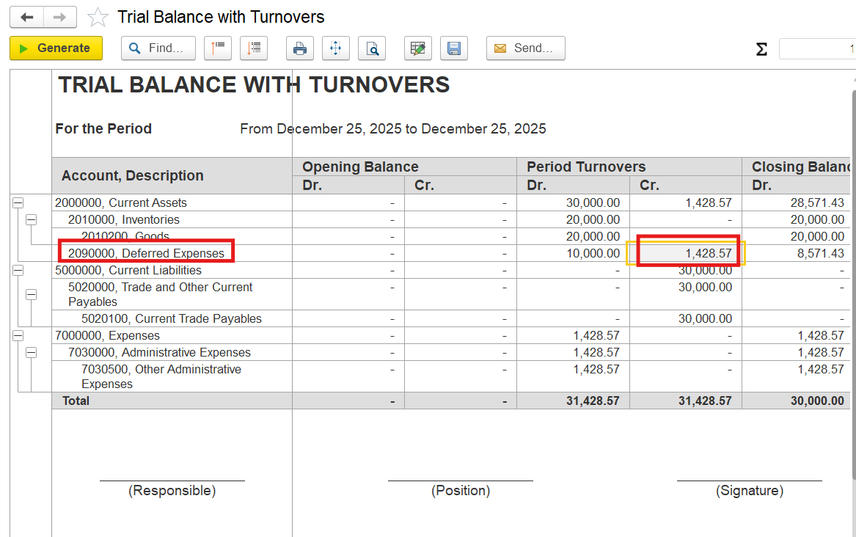
Deferred Expense balance Report
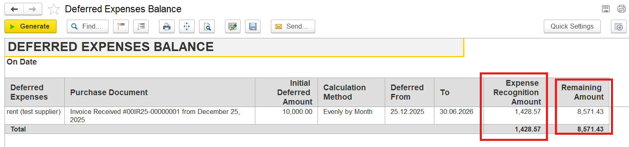

Revenue Recognition: for the service item the deferred option will be coming
You can add it up to the customer invoice 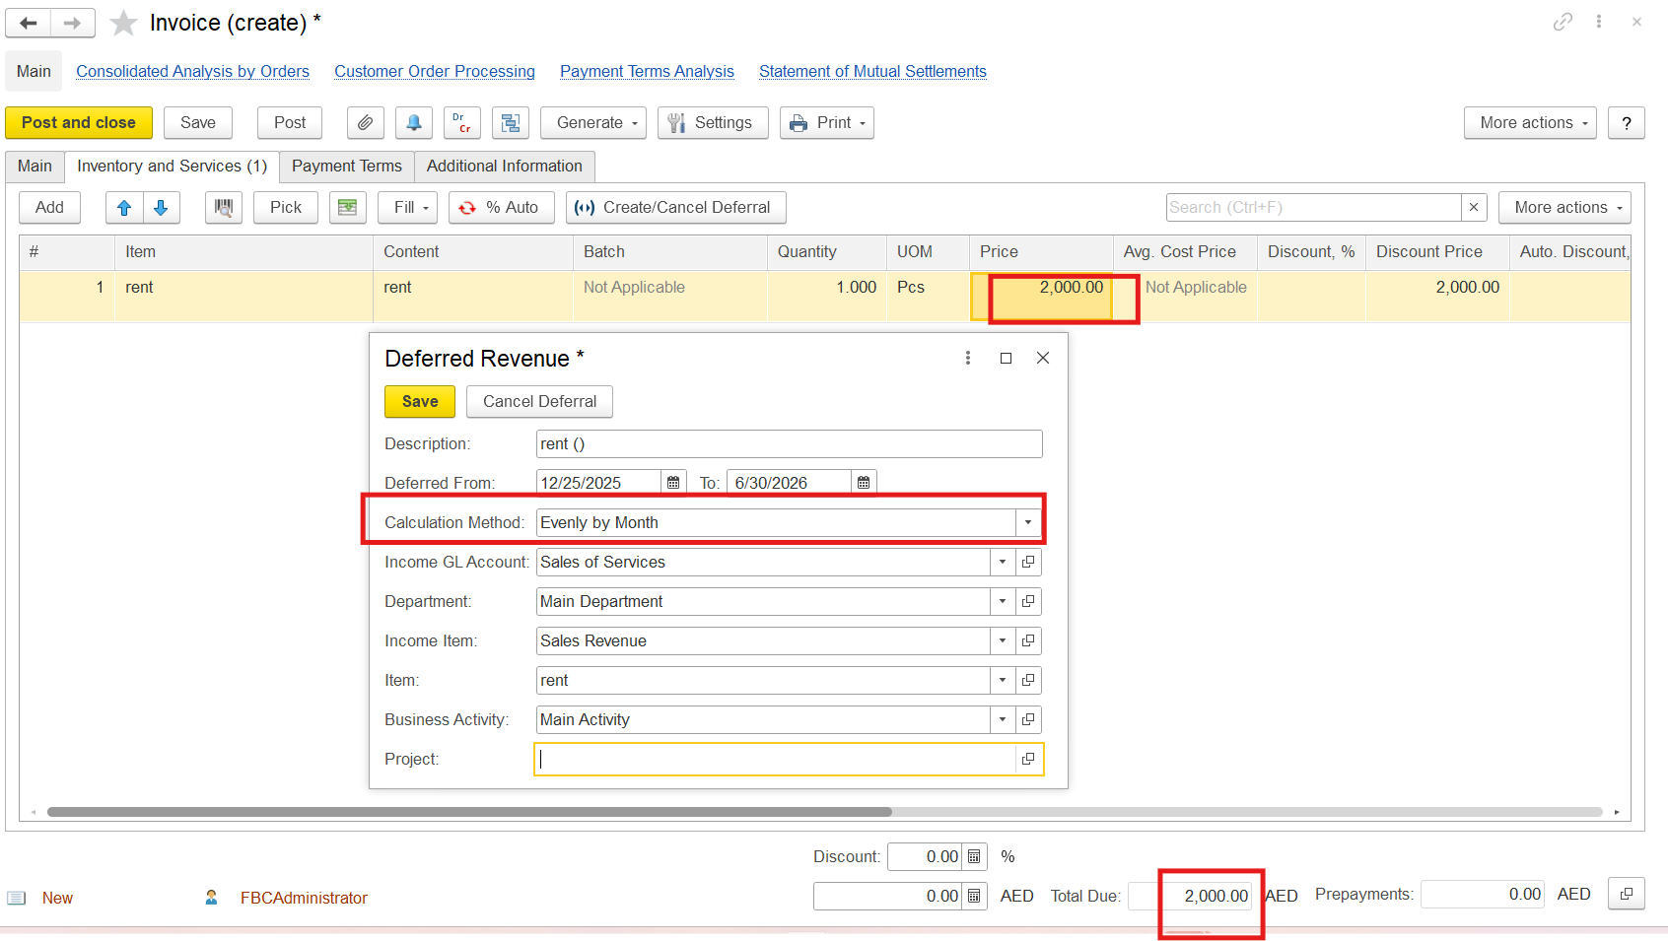
Then we will be entering the revenue recognitio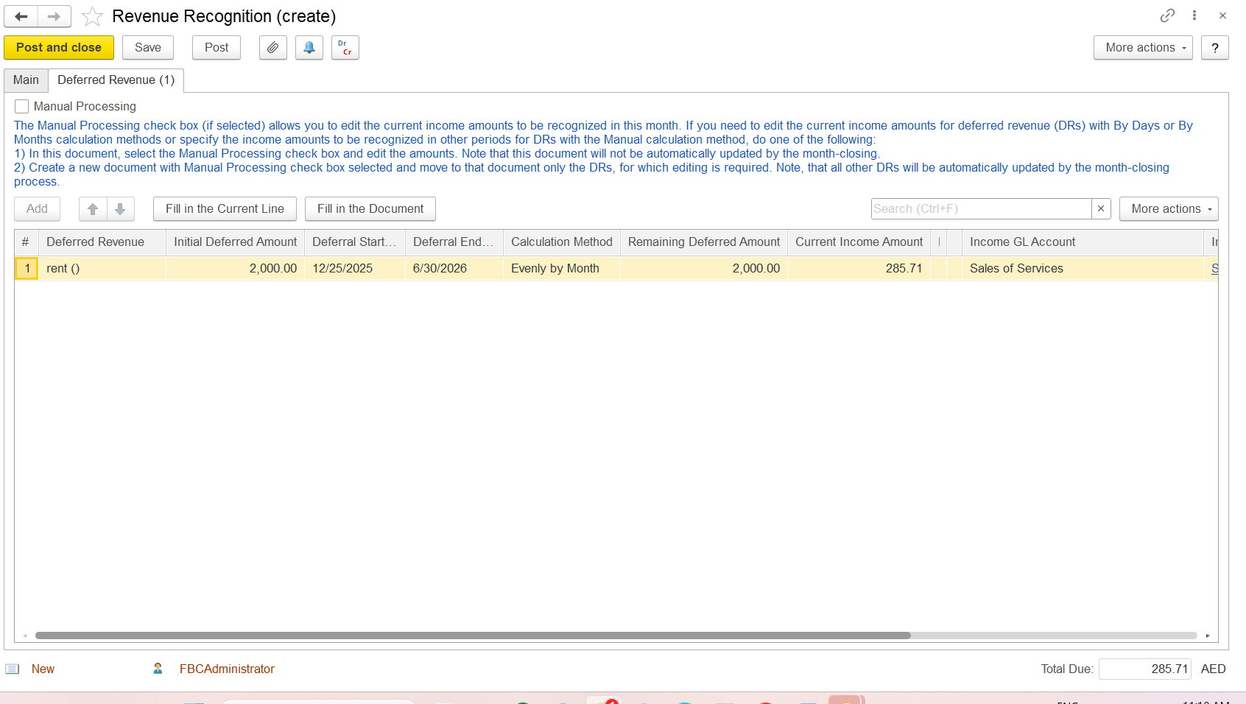
Check for the GL Account DR Deferred Revenue and Credit will be sales of services
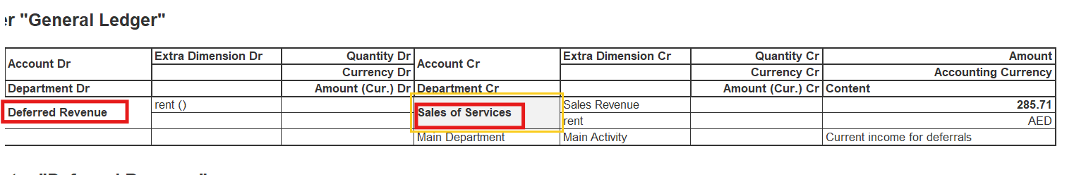
Trial balance: 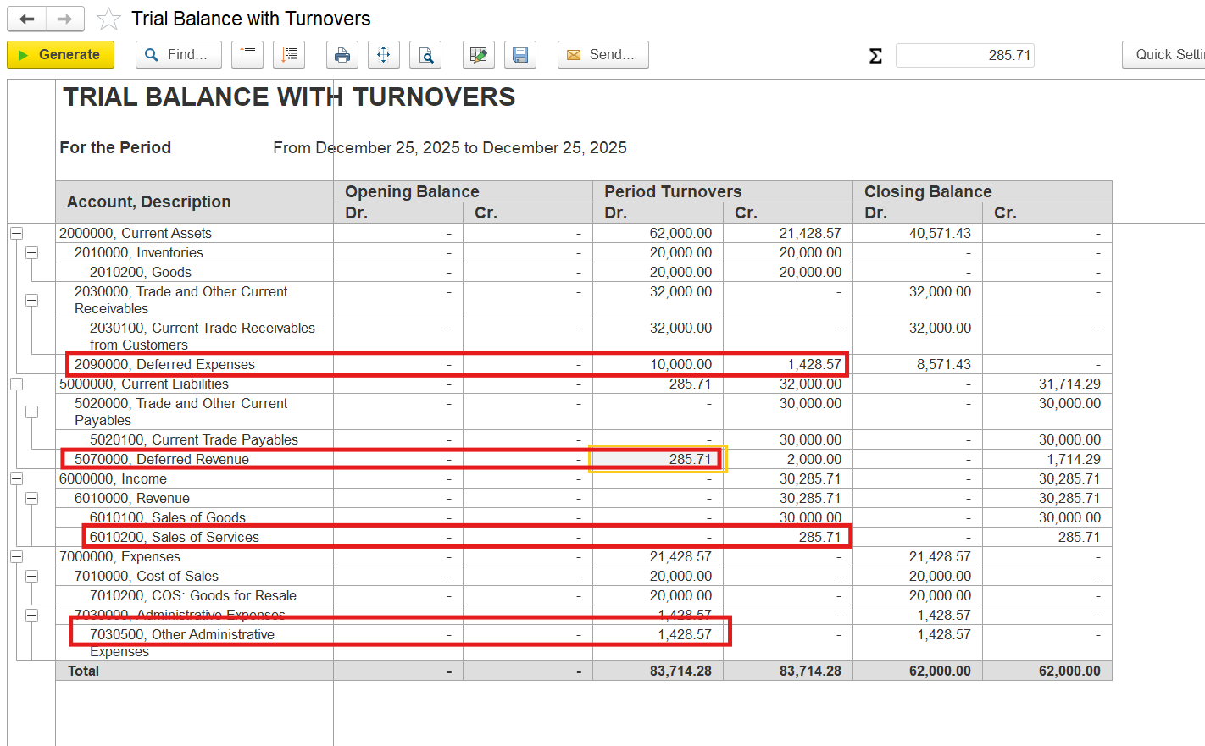

It will also reflect in the Income statement:
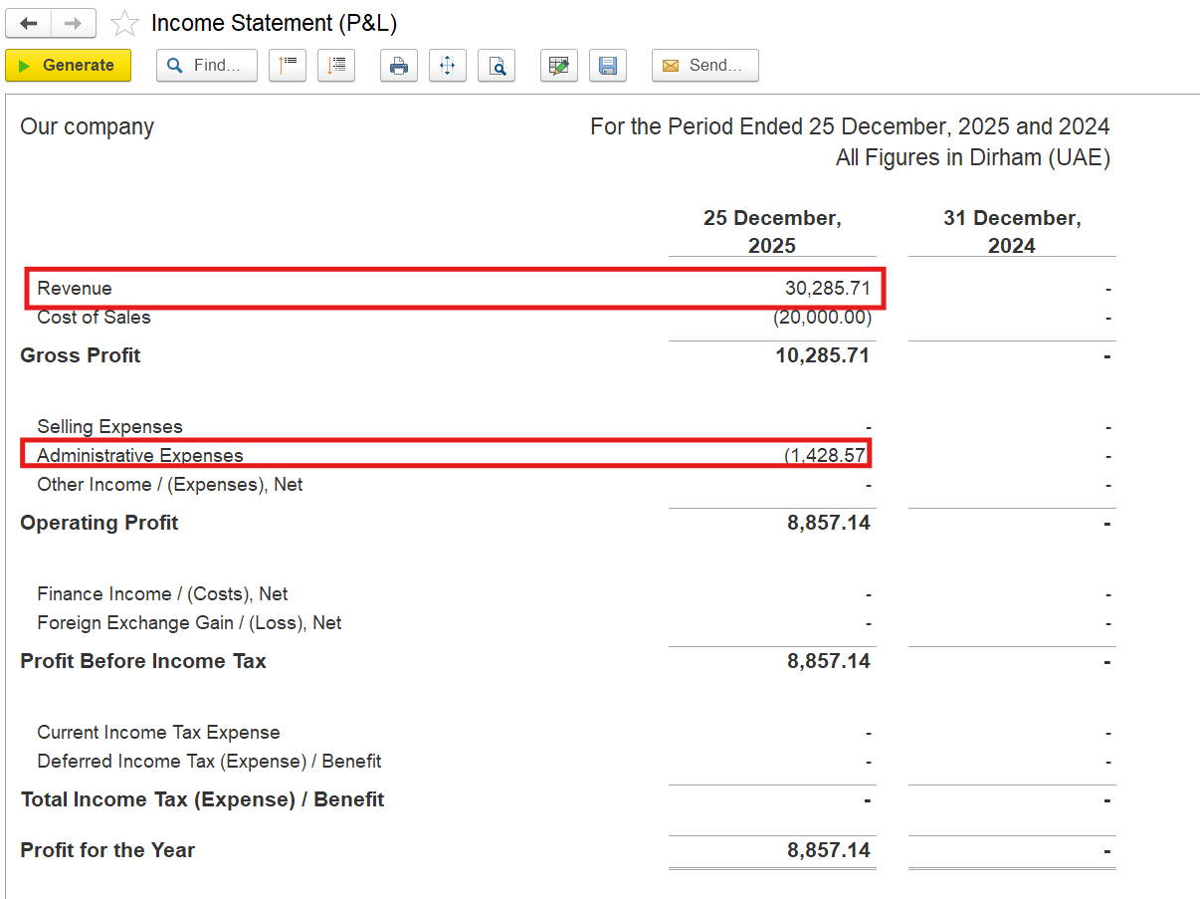
Click on drill down then it will show the specific Account 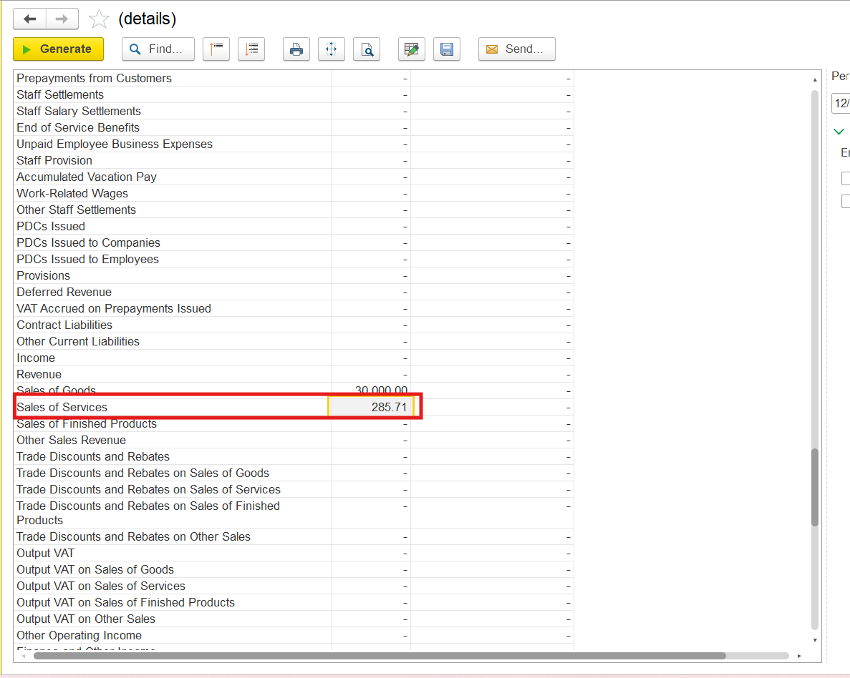

Deferrals Revenue adjustment you can adjust the end date GL Account and Calculation method it will open the similar page as of revenue recognition
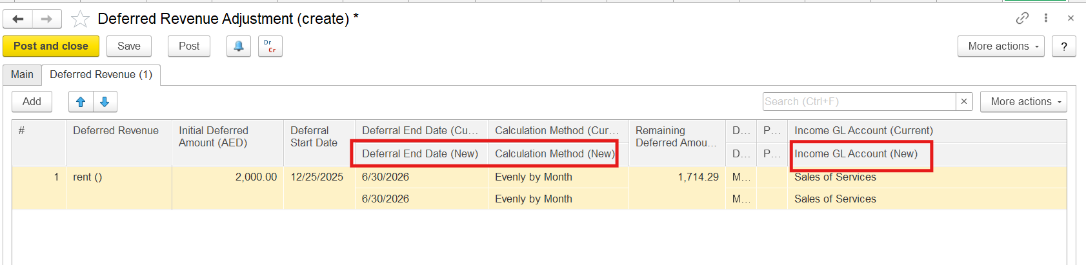

Defered revenue report will be generated
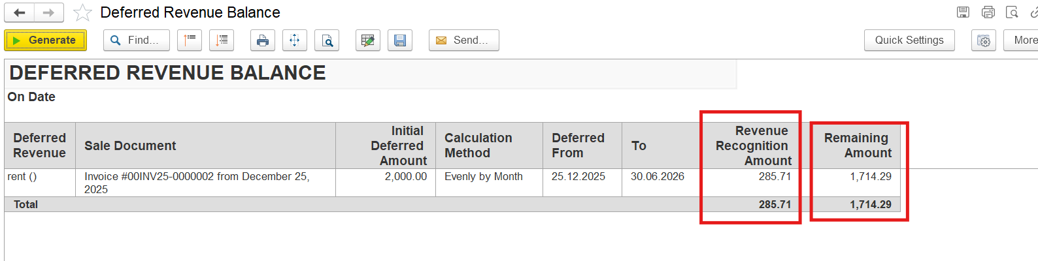

Opening Balances of the
*Customer, supplier Employee salary balances

